|  |
| --- |
| Electrical System Form FSAE-E2015 |
| The University of Akron |
| Akron Electric |
| Car E217 |
| [RCJ10@zips.uakron.edu](mailto:RCJ10@zips.uakron.edu) |

Table of Contents

Table of Contents iii

I List of Figures vii

II List of Tables viii

III List of Abbreviations ix

1 System Overview 2

2 Electrical Systems 4

2.1 Shutdown Circuit 4

2.1.1 Description/concept 4

2.1.2 Wiring / additional circuitry 7

2.1.3 Position in car 9

2.2 IMD 11

2.2.1 Description (type, operation parameters) 11

2.2.2 Wiring/cables/connectors/ 11

2.2.3 Position in car 12

2.3 Inertia Switch 13

2.3.1 Description (type, operation parameters) 13

2.3.2 Wiring/cables/connectors/ 13

2.3.3 Position in car 14

2.4 Brake Plausibility Device 14

2.4.1 Description/additional circuitry 14

2.4.2 Wiring 15

2.4.3 Position in car/mechanical fastening/mechanical connection 15

2.5 Reset / Latching for IMD and BMS 16

2.5.1 Description/circuitry 16

2.5.2 Wiring/cables/connectors 16

2.5.3 Position in car 16

2.6 Shutdown System Interlocks 17

2.6.1 Description/circuitry 17

2.6.2 Wiring/cables/connectors 17

2.6.3 Position in car 18

2.7 Tractive system active light 18

2.7.1 Description/circuitry 18

2.7.2 Wiring/cables/connectors 19

2.7.3 Position in car 20

2.8 Measurement points 20

2.8.1 Description 20

2.8.2 Wiring, connectors, cables 21

2.8.3 Position in car 22

2.9 Pre-Charge circuitry 23

2.9.1 Description 23

2.9.2 Wiring, cables, current calculations, connectors 23

2.9.3 Position in car 26

2.10 Discharge circuitry 27

2.10.1 Description 27

2.10.2 Wiring, cables, current calculations, connectors 28

2.10.3 Position in car 31

2.11 HV Disconnect (HVD) 32

2.11.1 Description 32

2.11.2 Wiring, cables, current calculations, connectors 32

2.11.3 Position in car 33

2.12 Ready-To-Drive-Sound (RTDS) 34

2.12.1 Description 34

2.12.2 Wiring, cables, current calculations, connectors 34

2.12.3 Position in car 35

3 Accumulator 36

3.1 Accumulator pack 1 36

3.1.1 Overview/description/parameters 36

3.1.2 Cell description 41

3.1.3 Cell configuration 41

3.1.4 Cell temperature monitoring 41

3.1.5 Battery management system 41

3.1.6 Accumulator indicator 45

3.1.7 Wiring, cables, current calculations, connectors 46

3.1.8 Accumulator insulation relays 46

3.1.9 Fusing 46

3.1.10 Charging 48

3.1.11 Mechanical Configuration/materials 49

3.1.12 Position in car 50

3.2 Accumulator pack 2 51

4 Energy meter mounting 52

4.1 Description 52

4.2 Wiring, cables, current calculations, connectors 52

4.3 Position in car 53

5 Motor controller 54

5.1 Motor controller 1 54

5.1.1 Description, type, operation parameters 54

5.1.2 Wiring, cables, current calculations, connectors 54

5.1.3 Position in car 56

5.2 Motor controller 2 56

6 Motors 57

6.1 Motor 1 57

6.1.1 Description, type, operating parameters 57

6.1.2 Wiring, cables, current calculations, connectors 58

6.1.3 Position in car 58

6.2 Motor 2 59

7 Torque encoder 60

7.1 Description/additional circuitry 60

7.2 Torque Encoder Plausibility Check 60

7.3 Wiring 61

7.4 Position in car/mechanical fastening/mechanical connection 62

8 Additional LV-parts interfering with the tractive system 63

8.1 LV part 1 63

8.1.1 Description 63

8.1.2 Wiring, cables, 63

8.1.3 Position in car 64

8.2 LV part 2 65

9 Overall Grounding Concept 66

9.1 Description of the Grounding Concept 66

9.2 Grounding Measurements 66

10 Firewall(s) 67

10.1 Firewall 1 67

10.1.1 Description/materials 67

10.1.2 Position in car 68

10.2 Firewall 2 68

11 Appendix 69

# List of Figures

Has to be hyperlinked!

# List of Tables

Table 1.1 General parameters 2

Table 2.1 List of switches in the shutdown circuit 7

Table 2.2 Wiring – Shutdown circuit 9

Table 2.3 Parameters of the IMD 11

Table 2.4 Parameters of the Inertia Switch 13

Table 7.1 Torque encoder data 14

Table 2.6 Parameters of the TSAL 19

Table 2.7 General data of the pre-charge resistor 25

Table 2.8 General data of the pre-charge relay 26

Table 2.9 General data of the discharge circuit 30

Table 3.1 Main accumulator parameters 40

Table 3.2 Main cell specification 41

Table 3.5 Wire data of company A, 0.205 mm² 46

Table 3.3 Basic AIR data 46

Table 3.4 Basic fuse data 47

Table 3.5 Fuse Protection Table 48

Table 3.6 General charger data 48

Table 5.1 General motor controller data 54

Table 5.2 Wire data of company A, 0.205 mm² 55

Table 6.1 General motor data 57

Table 7.1 Torque encoder data 60

Has to be hyperlinked!

# List of Abbreviations

* HV: High Voltage
* GLVS: Grounded Low Voltage System
* BMS: Battery Management System
* BMM: Battery Management System Master
* BMSS: Battery Management System Slave (S)
* SAS: Sensor Acquision System
* MCS: Motor Controller System
* SS: Safety System
* DDS: Dasboard Display System

# System Overview

The University of Akron’s electrical system concept splits the electrical system into the Tractive HV system, and the GLV control system. The tractive system includes the motors, motor controllers, batteries, AIR’s, main fuse, and part of the BMS. The GLV control system includes the control section of the BMS, sensors.

The vehicle is a single motor, rear wheel drive electric car. The motor is a79kW peak output power with a 3.5:1 gear ratio and a mechanical differential. Traction control is required to keep wheel slip to a minimum. The accumulator system consists of 280LiPo battery cells. They are connected in two accumulators that holds two 70 series sets.

|  |  |
| --- | --- |
| Maximum Tractive-system voltage: | 294VDC |
| Nominal Tractive-system voltage: | 231VDC |
| Control-system voltage: | 24VDC |
| Accumulator configuration: | 70s4p |
| Total Accumulator capacity: | 28.2Ah6.46 kWatt-hours; 29.68MJ |
| Motor type: | Permanent Magnet Brushless AC |
| Number of motors: | One |
| Maximum combined motor power in kW | 79kW |

Table 1.1 General parameters

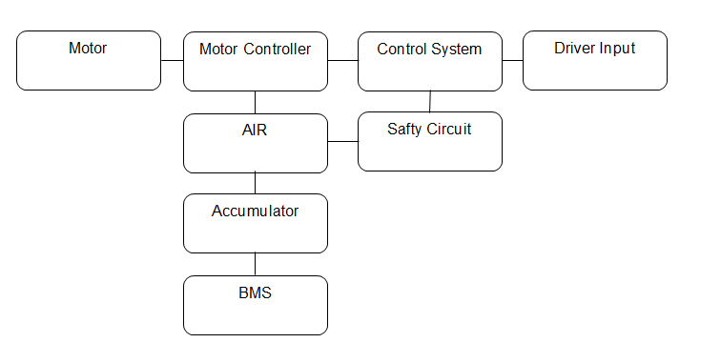

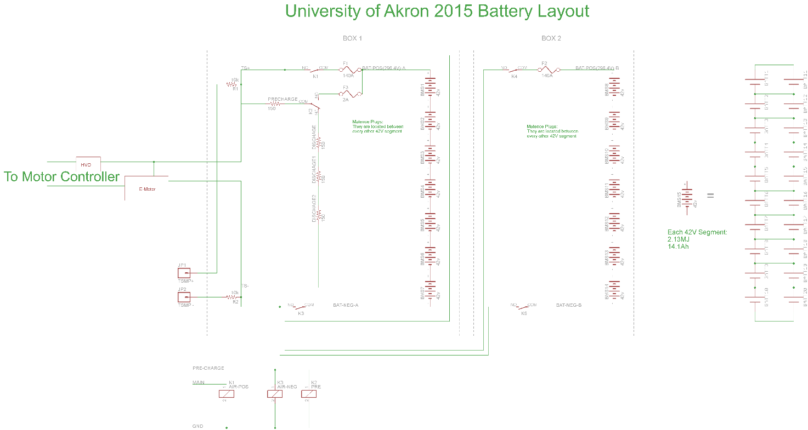

# Electrical Systems

## Shutdown Circuit

### Description/concept

The shutdown circuit carries the current to open or close the Accumulator Isolation Relays, providing several methods for shutting down the high voltage parts of the car in emergencies. All the emergency switches are connected in series so if one switch opens, the power is removed to the AIR’s. We do not use capacitors to hold open the AIR’s during a fault. The safety system gets its power from the GLVMS. The power supplied to the GLVMS is from our custom battery pack. The power after the GLVMS flows through the E-Stops and then to the safety circuits. These are controlled by digital hardware monitoring IMD, Brake pressure, current, and BMS issues. The ECU relay is to stop the car from precharging (EX: the car in a non-ready-to-drive state) until the start button is hit and brake pedal is depressed. Hence not allowing the car to be in a ready to drive mode when all external faults are clear. We do this to add hardware and software lockouts. The safety system faults that are AMS, IMD, or BSPD are only cleared with a car power down. That would require driver to have access to GLVMS and they do not. The shutdown system also examines where the fault is to alert the team what faulted. (10.14 E-Stop datasheet)

We are able to perform lockout at the TSMS by removing the red key. The safety officer keeps the one key on themselves. This prevents the car from being energized when in an unsafe condition. The key is unique enough that it would be hard to activate without it. This is demonstrated bellow:

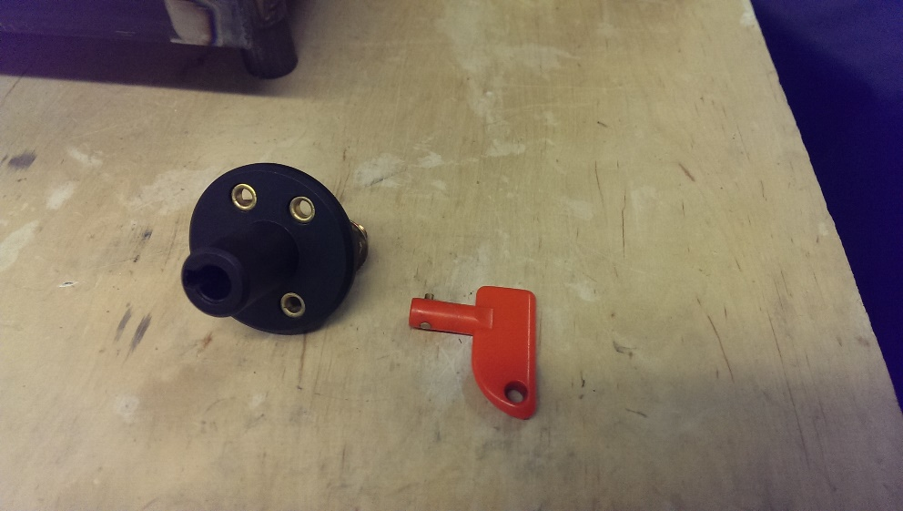

TSMS and GLVMS in the OFF position:

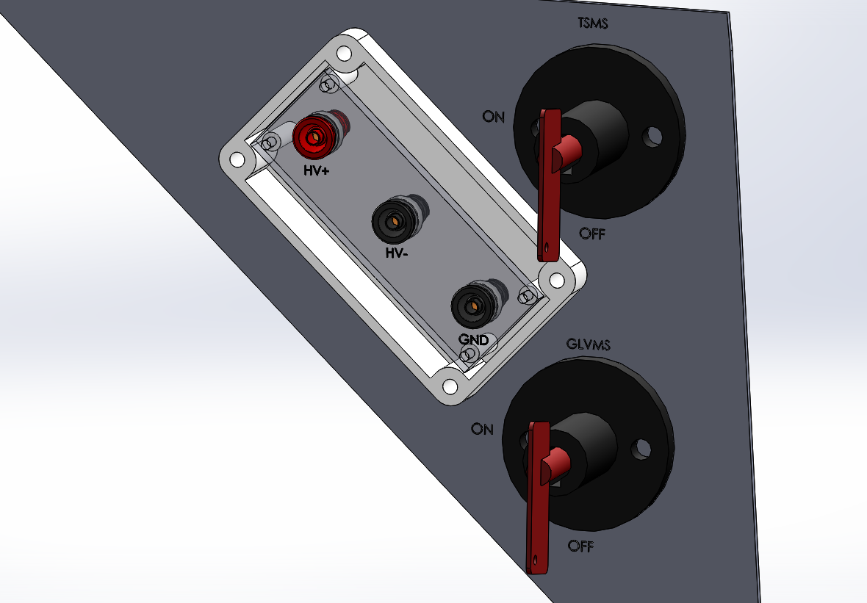

TSMS and GLVMS in the ON position:

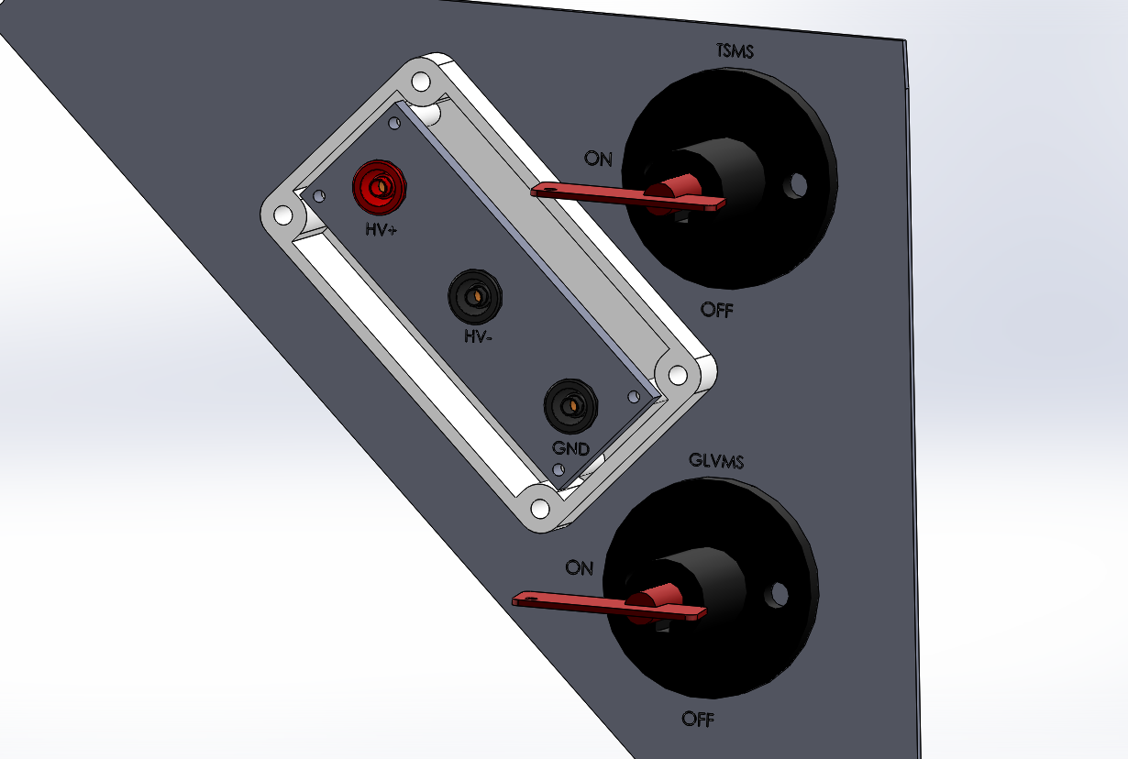

|  |  |
| --- | --- |
| Part | Function |
| Main Switch (for control and tractive-system; CSMS, TSMS) | Normally open |
| Brake over travel switch (BOTS) | Normally closed |
| Shutdown buttons (SDB) | Normally closed |
| Insulation Monitoring Device (IMD) | Normally closed |
| Battery Management System (BMS) | Normally closed |
| Inertia Switch | Normally closed |
| Interlocks | Closed when circuits are connected |
| Brake System Plausibility Device | Normally Closed |
| Software system (ECU) | Normally Closed |

Table 2.1 List of switches in the shutdown circuit

### Wiring / additional circuitry

Please see figure 2.9.2 for Precharge Control circuit

Inertia Switch

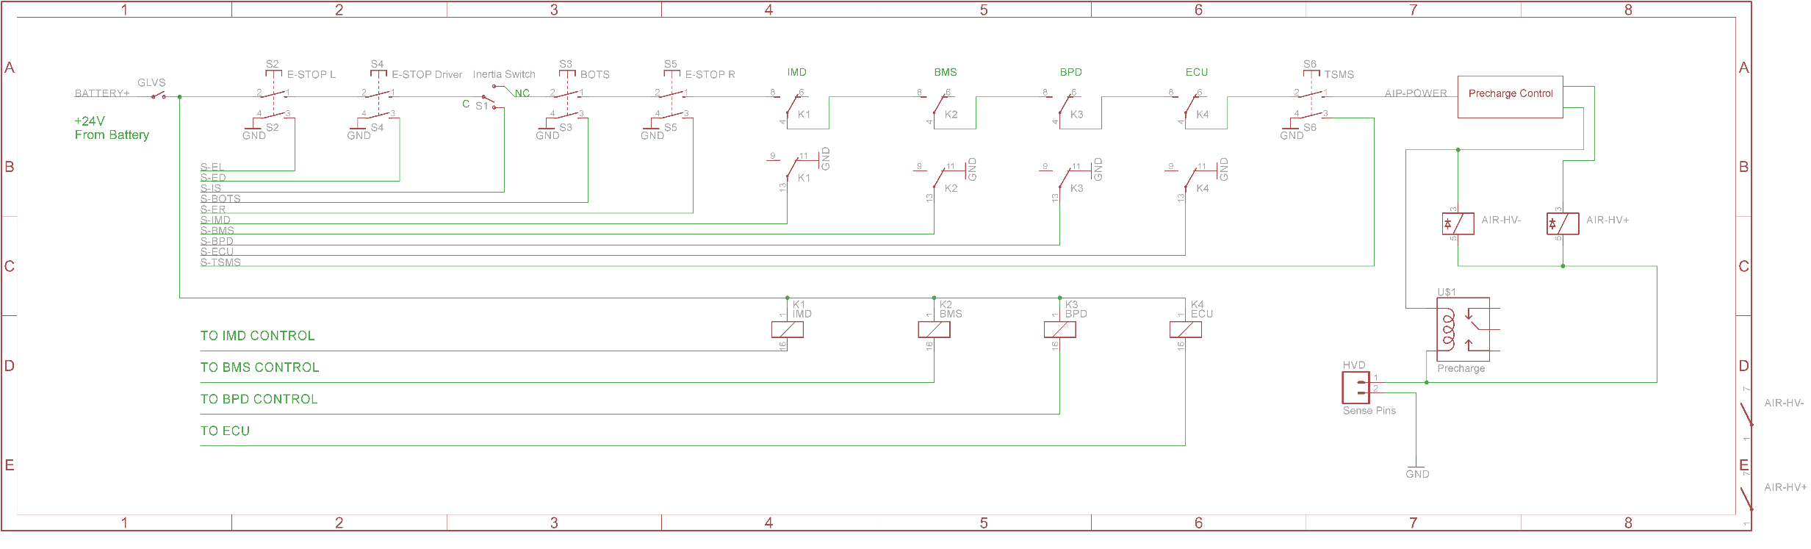

Precharge and Discharge control

AIR

Main and Pre+ are outputs of the pre charge control circuitry.

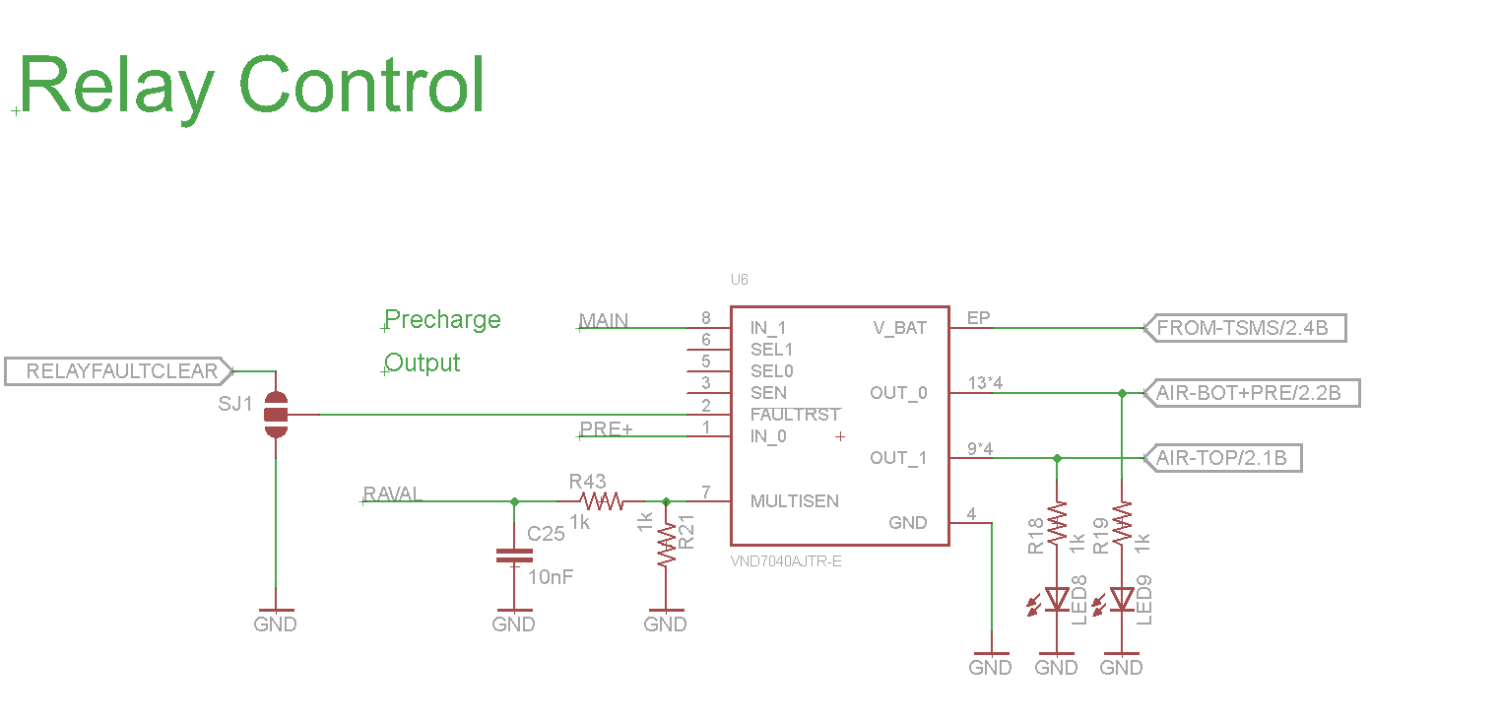

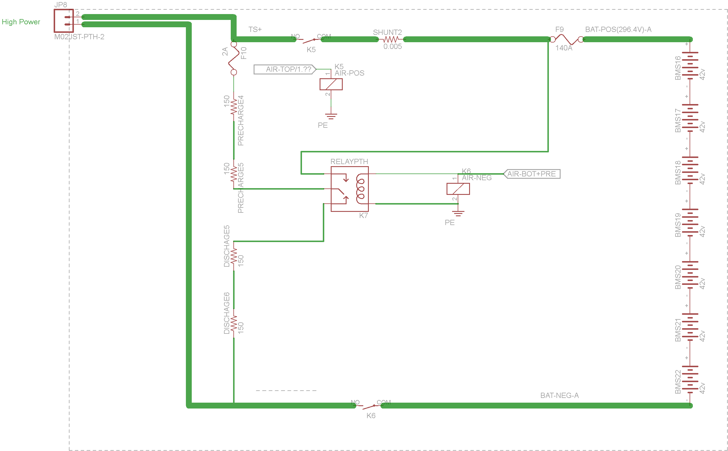

|  |  |
| --- | --- |
| Total Number of AIRs: | 4 |
| Current per AIR: | 0.25A |
| Additional parts consumption within the shutdown circuit: | 1A |
| Total current: | 2A |
| Cross sectional area of the wiring used: | 2.1mm² |

Table 2.2 Wiring – Shutdown circuit

### Position in car

Disconnect, driver e-stop, and left e-stop:

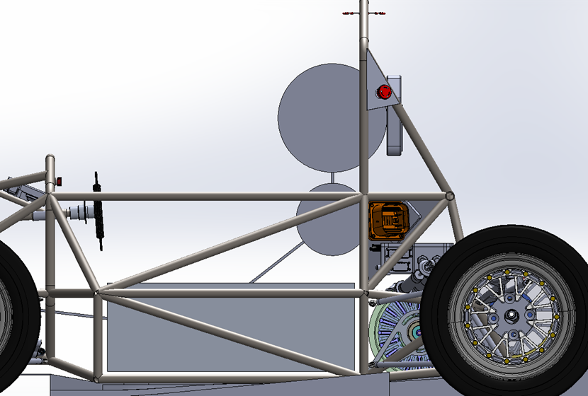

E-Stop Datasheet

The driver can reset the crash sensor or driver estop if necessary.

Driver e-stop, right e-stop and left e-stop:

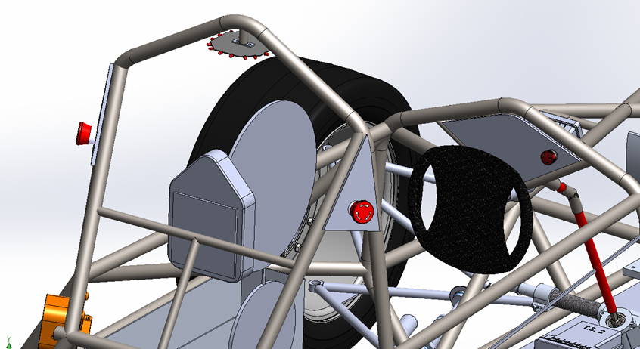

BOTS:

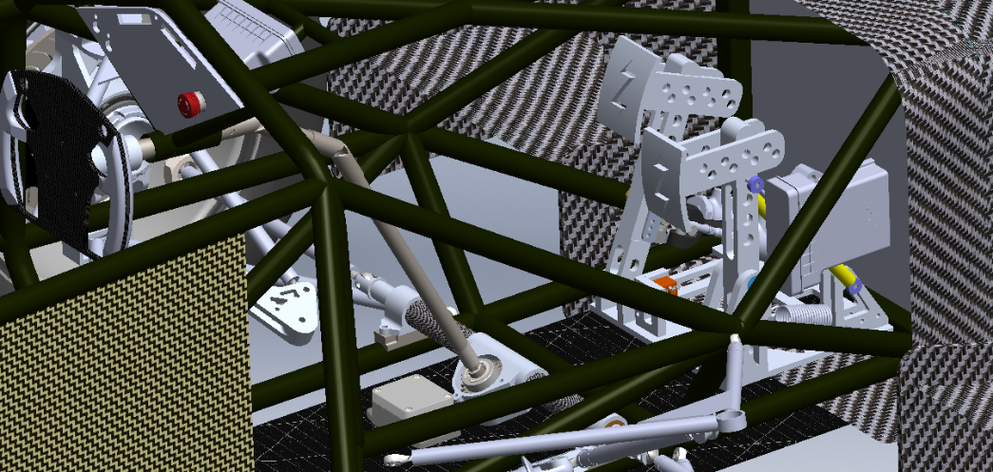

Inertia Switch:

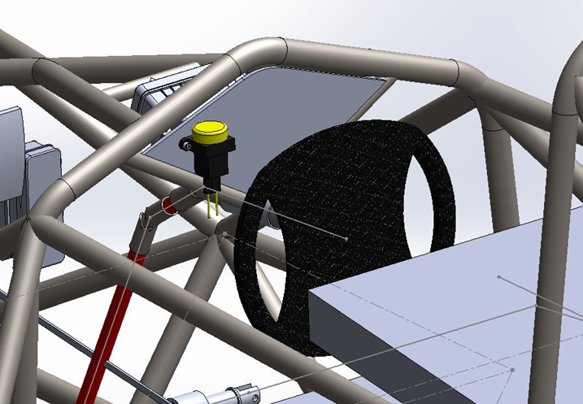

## IMD

### Description (type, operation parameters)

Bender A-Isometer IR-155-3203, Automatic Device Self-test and Continuous measurement of insulation resistance. The indicator is wired to the front dash. The LED is lit by software cue from the safety system (SS) to the Dashboard Display System DDS controller warning the driver. The system is not able to be reset unless there is a GLVMS power cycle.

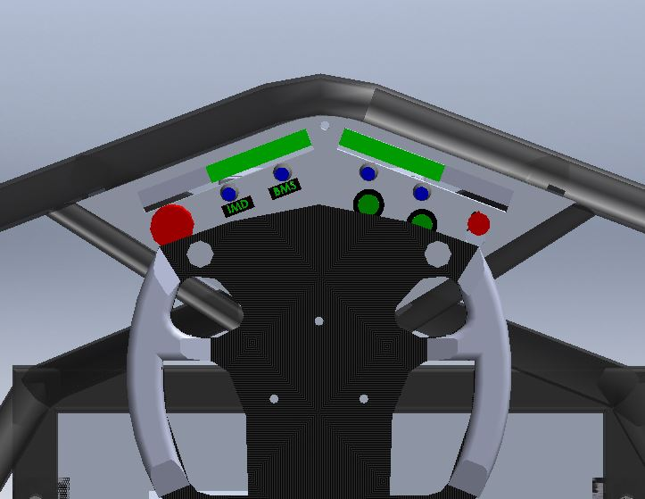

|  |  |
| --- | --- |
| Supply voltage range: | 10..36VDC |
| Supply voltage | 24VDC |
| Environmental temperature range: | -40..105°C |
| Selftest interval: | Always at startup, then every 20 minutes |
| High voltage range: | DC 0..1000V |
| Set response value: | 300kΩ (500Ω/Volt) |
| Max. operation current: | 500mA |
| Approximate time to shut down at 50% of the response value: | 27s |

Table 2.3 Parameters of the IMD

### Wiring/cables/connectors

The IMD requires 24 Gauge PVC wire with a 300v and 105C rating.

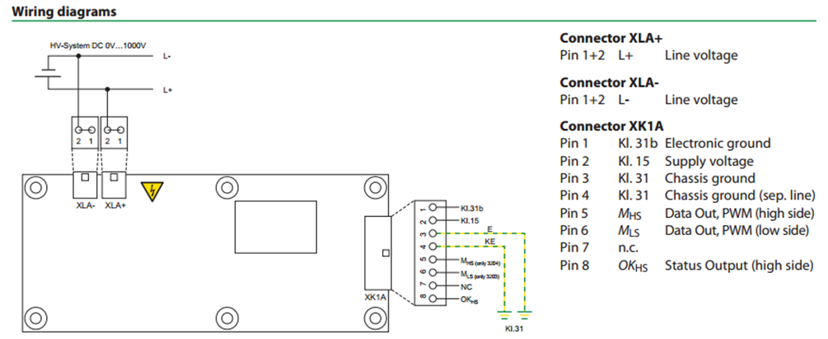

### Position in car

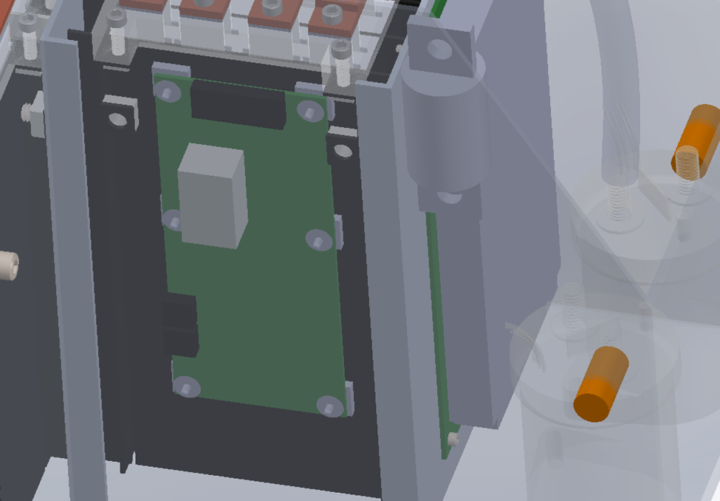

## Inertia Switch

### Description (type, operation parameters)

The inertia switch will be normally closed and will open to shut down the tractive system in the event of a crash. This is hooked up in series with the other safety switches that control the AIR’s so if it went off the tractive system would become unpowered. The driver will have the ability to depress the Sensata crash sensor to reset it. The crash sensor is removable off the dashboard with two screws and an electrical connector to test the device at competition. 10.5 Datasheet

|  |  |
| --- | --- |
| Inertia Switch type: | Sensata Resettable crash sensor |
| Supply voltage range: | 10..36VDC |
| Supply voltage: | 24VDC |
| Environmental temperature range: | -40..105°C |
| Max. operation current: | 10A |
| Trigger characteristics: | 6g for 50ms / 11g for 15ms |

Table 2.4 Parameters of the Inertia Switch

### Wiring/cables/connectors/

The crash sensor will be rigidly mounted to the frame of the car near the bottom to ensure that it receives the full force of any vibration or impact using a mating connector and 18 AWG, PVC, 105 C, 300v wire will be used for the electrical connections.

### Position in car



## Brake Plausibility Device

## Description/additional circuitry

The purpose of the brake plausibility system is to ensure that the brake pedal does not pass a certain threshold if the motors are being driven. It will work by using brake pressure on the brake pedal to measure braking and a current sensor on the connection between the accumulator and motor controllers to measure the current. These measured values will be compared by op-amps to pre-calculated constant threshold values set by potentiometers. The current set point is at 16.6A. To reset this system, it requires a GLVMS power cycle.

|  |  |
| --- | --- |
| Brake sensor used: | PX2AF1XX500PAAAX (data sheet here) |
| Torque encoder (current sensor) used: | MLX91205 |
| Supply voltages: | 5V |
| Maximum supply currents: | 20mA |
| Operating temperature: | -40..100 °C |
| Output used to control AIRs: | Open a relay |

Table 2.5 Torque encoder data

## Wiring

The brake plausibility system takes a 9V power input from the LV power system, along with 0-5Vdigital sensor input from the brake pedal sensor and the current sensor on the motor supply. The only output is the on or off 24v relay power that goes to the shutdown circuit. The reset of this system is done by power cycling the GLVS or hitting the reset button. The TSAL uses 24 Gauge PVC wire with a 300v and 105C rating. 10.16 datasheet

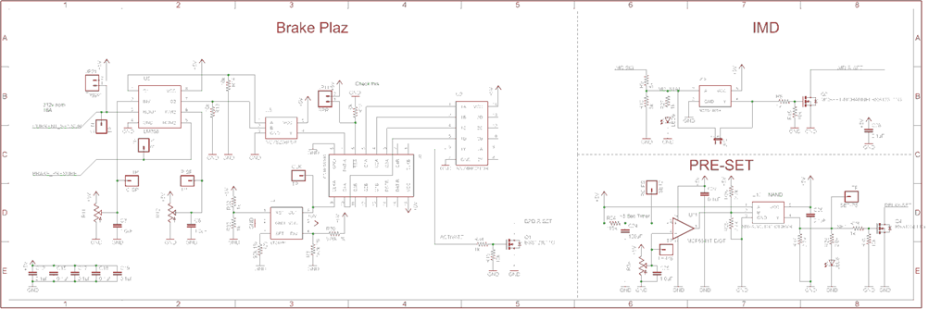

## Position in car/mechanical fastening/mechanical connection

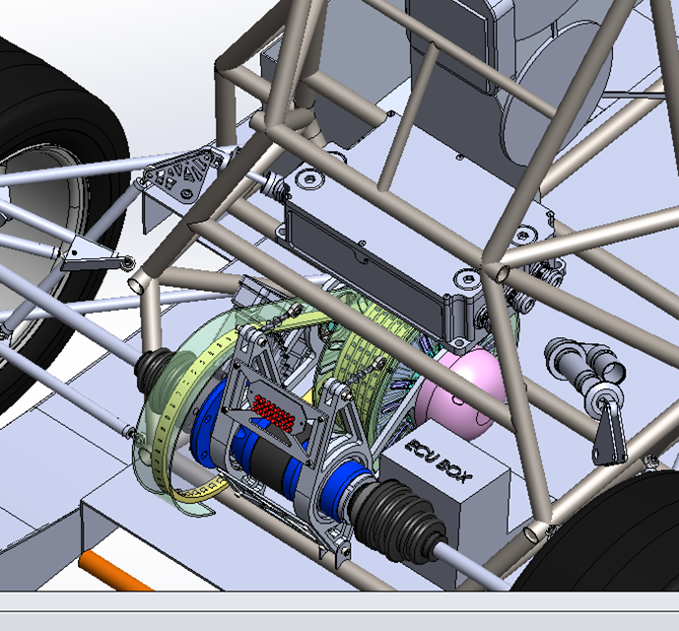

## Reset / Latching for IMD and BMS

### Description/circuitry

If the IMD or BMS becomes tripped, the latching relays will open. A GLVS power cycle will reset these systems or pushing the reset button. The latching relays are set by the PRE-SET circuit. Below is the IMD hardware Safety System. The BMS is done in software but is only reset (turned on) during startup.



### Wiring/cables/connectors

The BMS and IMD relay is wired into the shutdown system in series with other safety systems. This is wired with The TSAL uses 24 Gauge PVC wire with a 300v and 105C rating. The BMS has a relay on the PCB that it can trip to open the shutdown circuit. 10.16 wire datasheet

### Position in car

IMD:

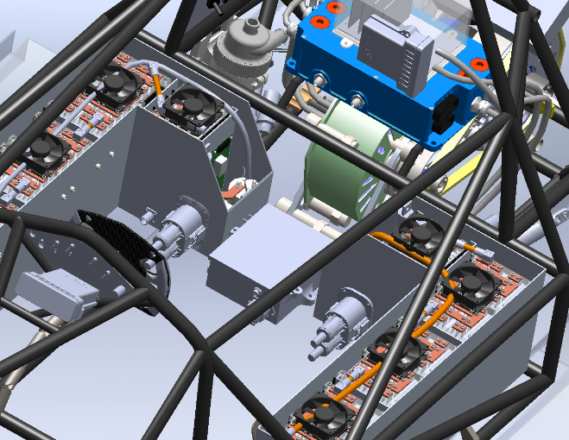

Control circuitry:

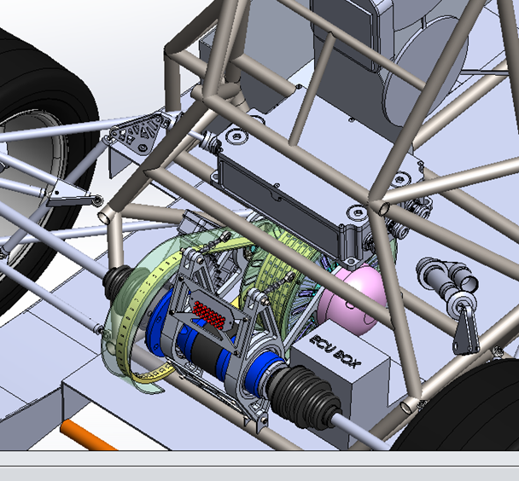

## Shutdown System Interlocks

### Description/circuitry

The interlocks are achieved by using sense low voltage isolated pins in the connectors to detect open or closed connections. The AIR’s power travel threw them. We have interlocks between the HVD. All other connectors will require tools to open.

### Wiring/cables/connectors

The HVD requires 18 Gauge PVC wire with a 300v and 105C rating.

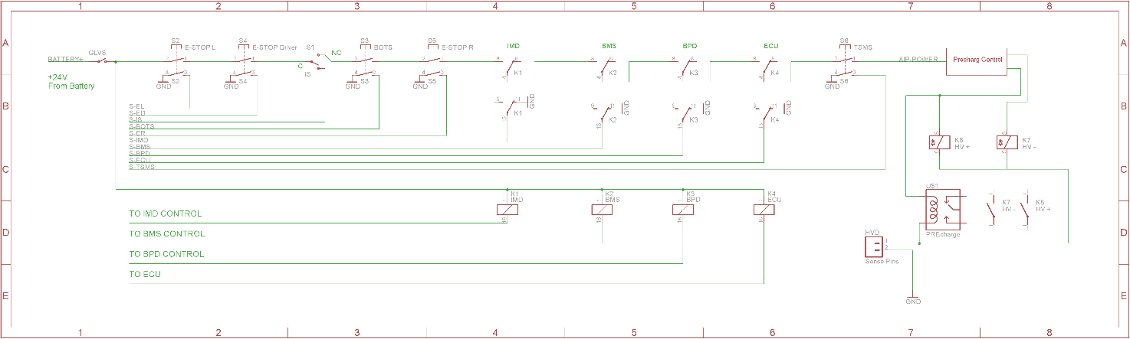

### Position in car

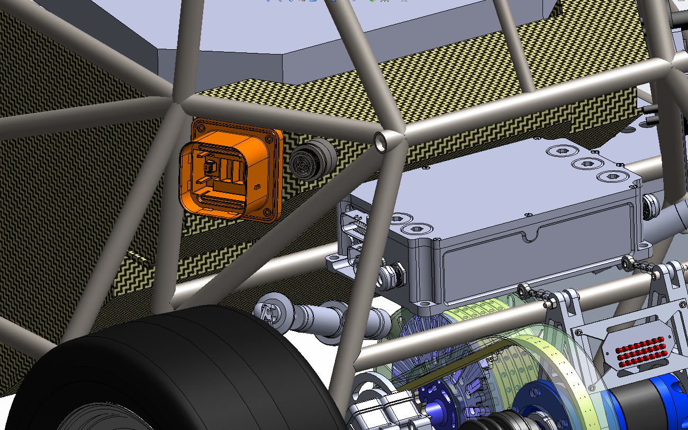

## Tractive system active light

### Description/circuitry

The TSAL consists of 16 LED’s mounted every 45 degrees to form an octagon with 2 LED’s on each side. The 3 Hz flashing frequency is driven by a 555 timer. This is turned on by a high voltage sensor after the AIR’s (power to the motor controller) in the battery pack. (Shown below)

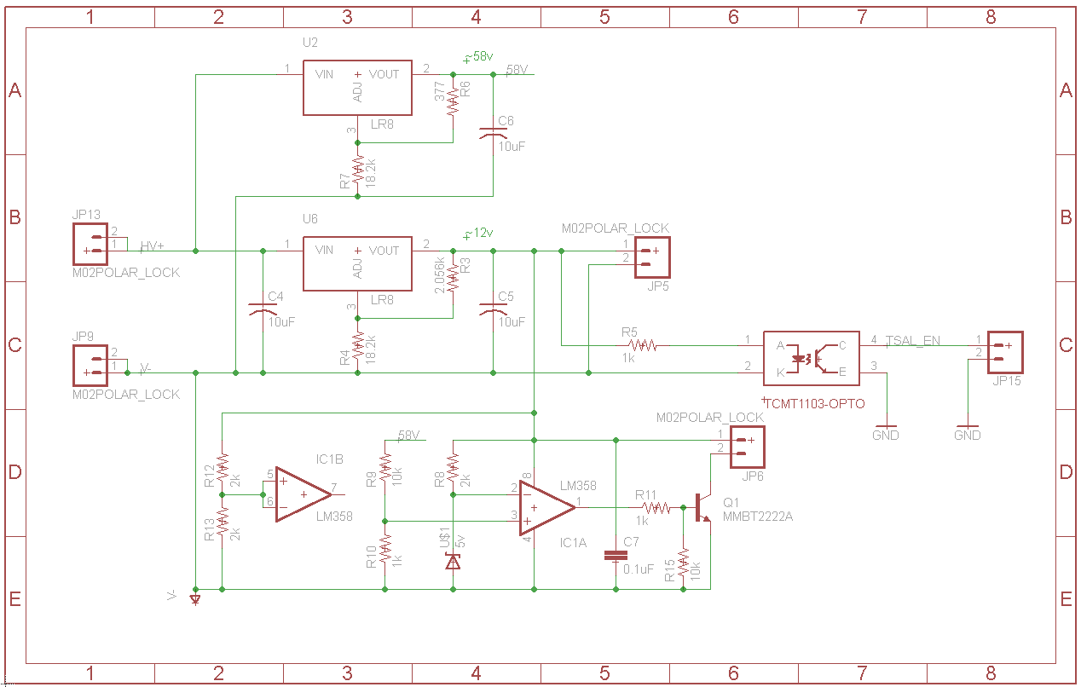

|  |  |
| --- | --- |
| Supply voltage: | 24VDC |
| Max. operational current: | 40mA |
| Lamp type | LED |
| Power consumption: | 1 W |
| Brightness | 100 Lumen |
| Frequency: | 1.5Hz |
| Size (length x height x width): | 20mm x 10mm x 50mm |

Table 2.6 Parameters of the TSAL

### Wiring/cables/connectors

The TSAL uses 24 Gauge PVC wire with a 300v and 105C rating. 10.16 datasheet

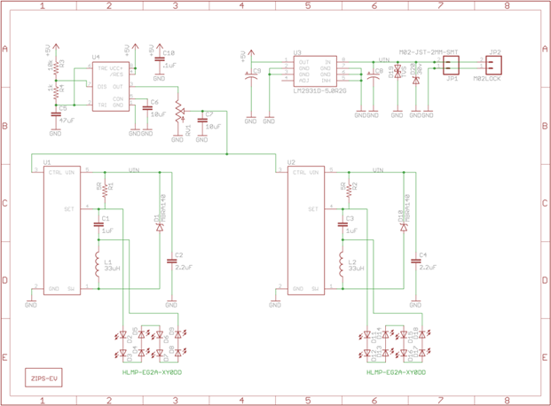

### Position in car

The TSAL is mounted to the bottom of the main roll hoop as required by the rules. It will be mounted with a metal bracket if necessary.

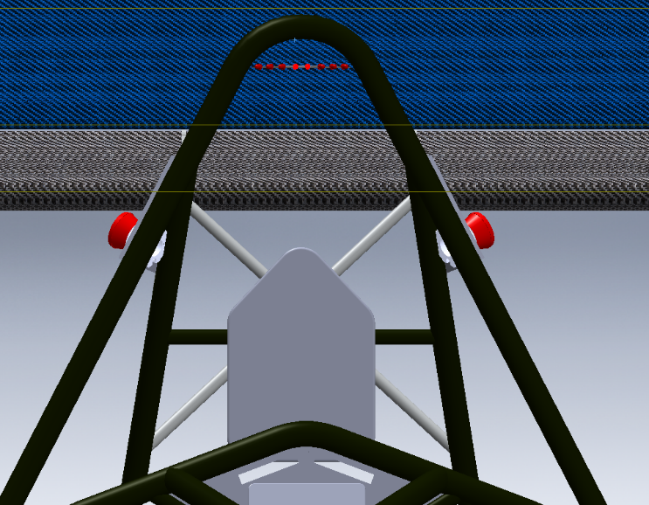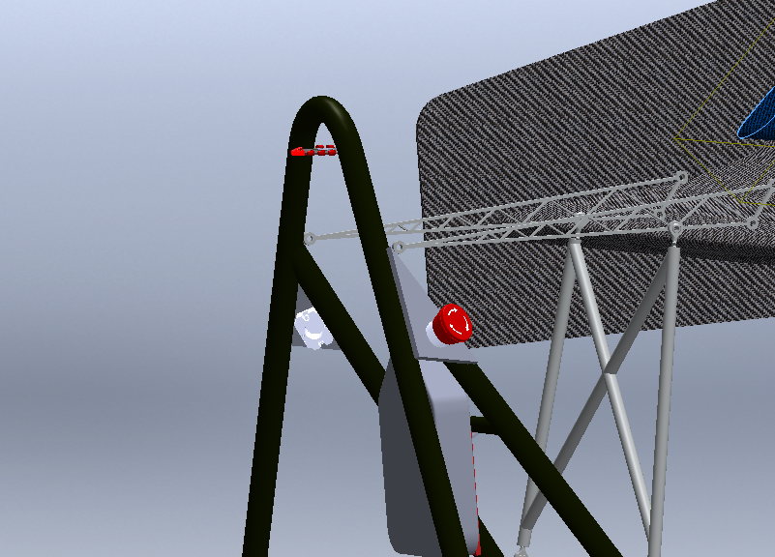

## Measurement points

### Description

4mm red and black banana jacks will be used to allow tractive system voltage measurement. They sit in an IP67 plastic box that has thumb screws holding on the cover. The box is UL Listed to UL508-4x, 12, & 13 specifications. 10.11 Jack Datasheet 10.12 Resistor Datasheet 10.15 Wire Info



### Wiring, connectors, cables

The TSMP 24 Gauge PVC wire with a 300v and 105C rating wire will connect the banana jacks in line with a 10kOhm resistor to the HV+ and HV- connections after the AIR’s.

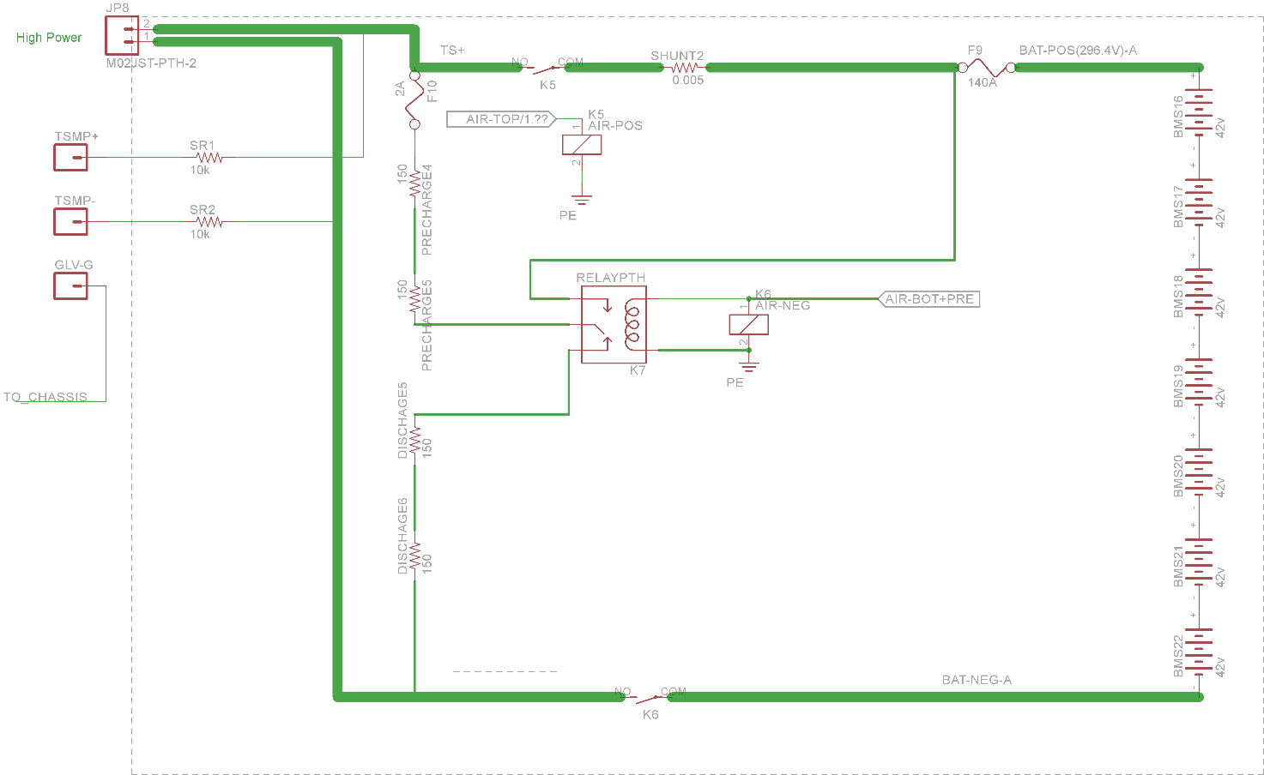

### Position in car

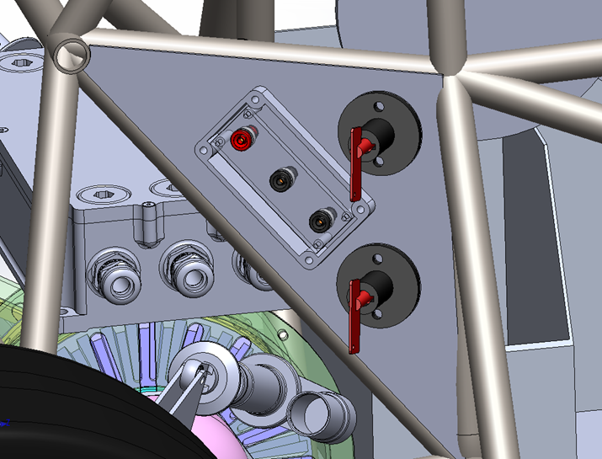

## Pre-Charge circuitry

### Description

The Pre-Charge system of the car is used to equalize the potential of the across the AIR switch and both battery packs. Pre-Charge started when the safety system is all clear of faults. This includes the ECU clearing its fault and setting the ready to drive relay. Bottom or negative relay turns on with the Pre-Charge relay in series with two 150 ohm resistors. The hardware then waits 2.5 seconds. This 2.5 second delay originates from the safety system board. This is set by an RC timer. After the 2.5 seconds are up, the Pre-Charge relay stays on and the AIR’s turn on shorting out the Pre-Charge resistor. During Pre-Charge, the car is acquiring data from the motor controller to verify voltage is present and increasing on the battery input to the device. If this doesn’t happen, the car will trip ECU safety stop and report an error code. The Control circuitry is not near the high voltage.

### Wiring, cables, current calculations, connectors

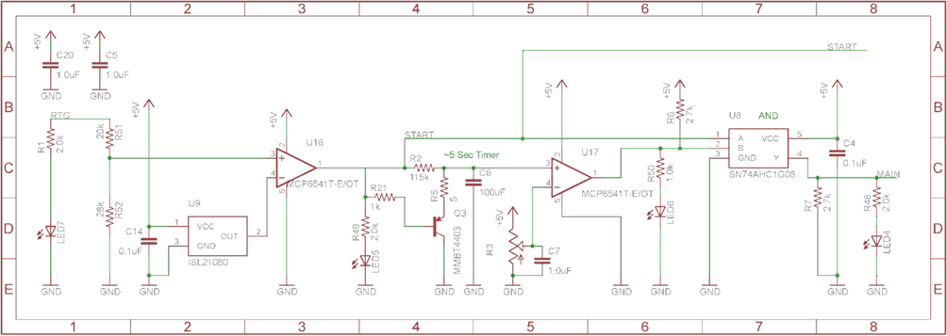



Formula = $1-{294.2}^{\frac{-t}{150*0.00088}}$

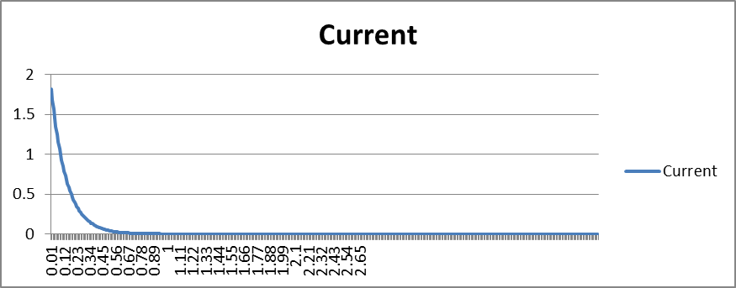

Formula = $294.2*{2.7182}^{\frac{-t}{150*0.00088}}$

|  |  |
| --- | --- |
| Resistor Type: | WFH160L150JE - Wirewound |
| Resistance: | 150Ω |
| Continuous power rating: | 160W |
| Overload power rating: | 160W |
| Voltage rating: | 600V |
| Cross-sectional area of the wire used: | 1.31mm² |

Table 2.7 General data of the pre-charge resistor

|  |  |
| --- | --- |
| Relay Type: | 5501-24-1 |
| Contact arrangment: | SPST-NO |
| Continuous DC current: | 3A |
| Voltage rating | 7500VDC |
| Cross-sectional area of the wire used: | 1.31mm² |

Table 2.8 General data of the pre-charge relay

### Position in car

Relay and resistor (in accumulator)

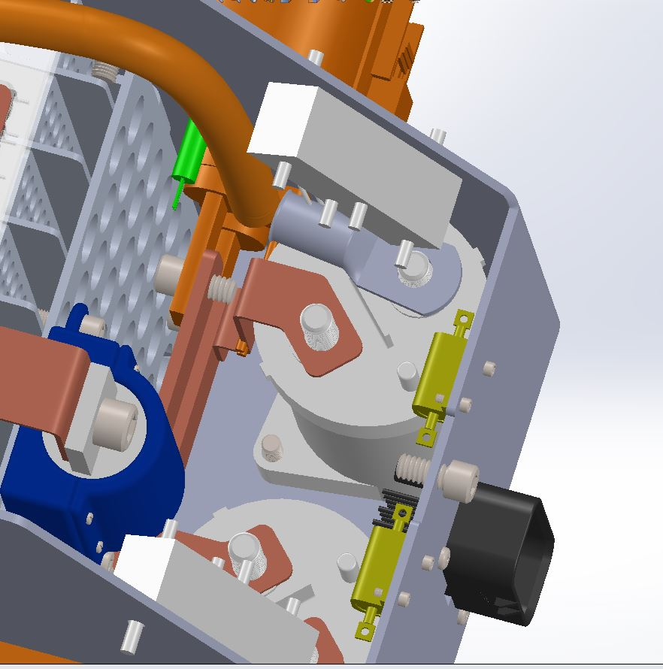

Relay

Resistor

Control system:

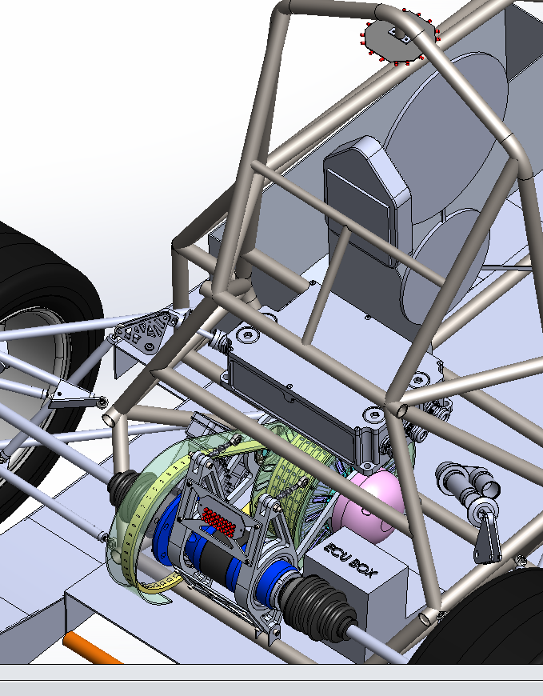

## Discharge circuitry

### Description

Our system requires a discharge system to get the capacitive energy out of the motor controller. Our system uses a resistor to drop the energy. We are able to discharge the energy in about 1.8 seconds. This circuit works off of the inverted precharge system relay output. It works by being a normally closed relay shorting the output of the accumulators and only opens when the precharge system activates and main AIRs open.

### Wiring, cables, current calculations, connectors

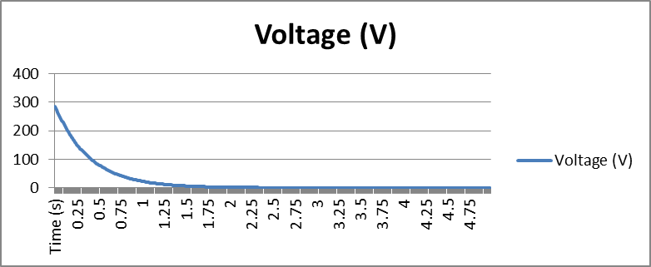

Formula = $\frac{294.2}{450}{2.7182}^{\frac{-t}{150*0.00088}}$

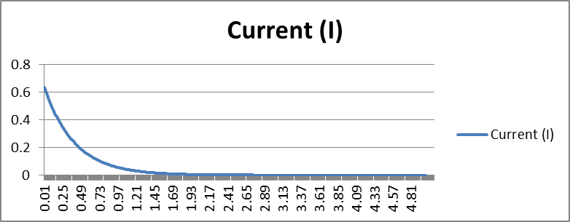

Formula = $294.2*{2.7182}^{\frac{-t}{150*0.00088}}$

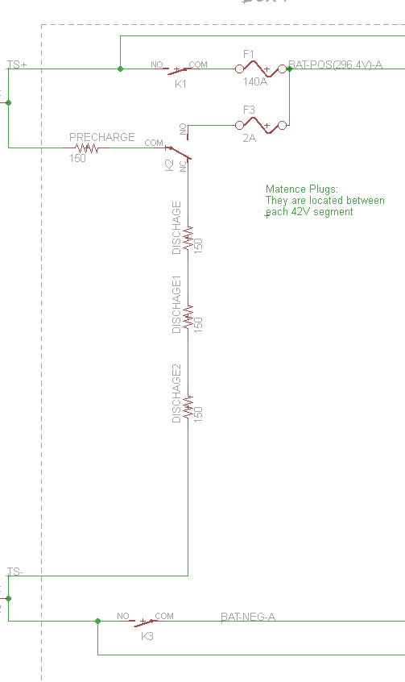

Precharge and discharge placement

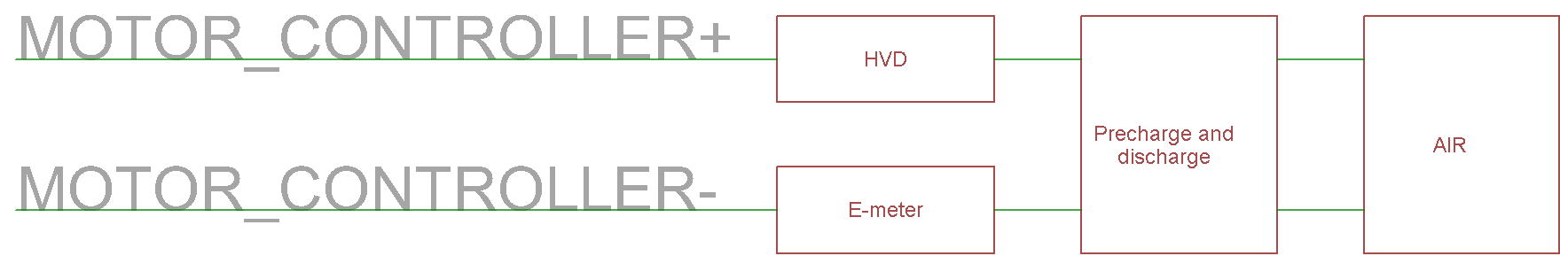

|  |  |
| --- | --- |
| Resistor Type: | WFH160L150JE - Wirewound |
| Resistance: | 450Ω |
| Continuous power rating: | 160W |
| Overload power rating: | 160W |
| Voltage rating: | 600V |
| Maximum expected current: | 0.7A |
| Average current: | 0.4A |
| Cross-sectional area of the wire used: | 1.31 mm² |

Table 2.9 General data of the discharge circuit

|  |  |
| --- | --- |
| Relay Type: | 5502-24-1 |
| Contact arrangment: | SPST-NC |
| Continuous DC current: | 3A |
| Voltage rating | 7500VDC |
| Cross-sectional area of the wire used: | 1.31 mm2 |

Table 2.10 General data of the dis-charge relay

### Position in car



Relay Resistor

Control system:



## HV Disconnect (HVD)

### Description

The HVD is a 1-1587987-7 (10.13 Datasheet for HVD) model from TE connectivity. It is a member of their Series B connector family and is capable of 630Amps and 450V. It is disconnected by a pull handle.

### Wiring, cables, current calculations, connectors

Wire - EXRAD-FSX1X 1 couple.

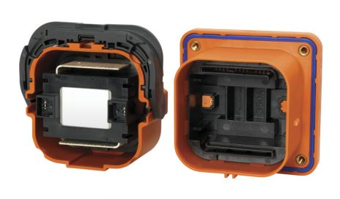

### Position in car

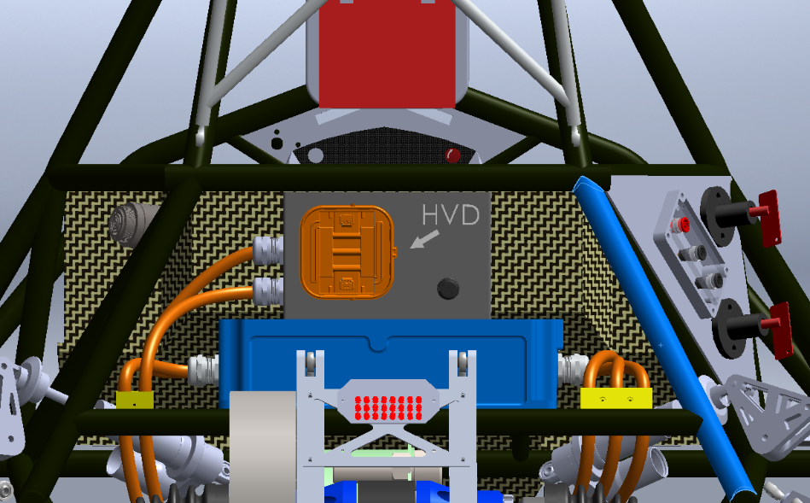

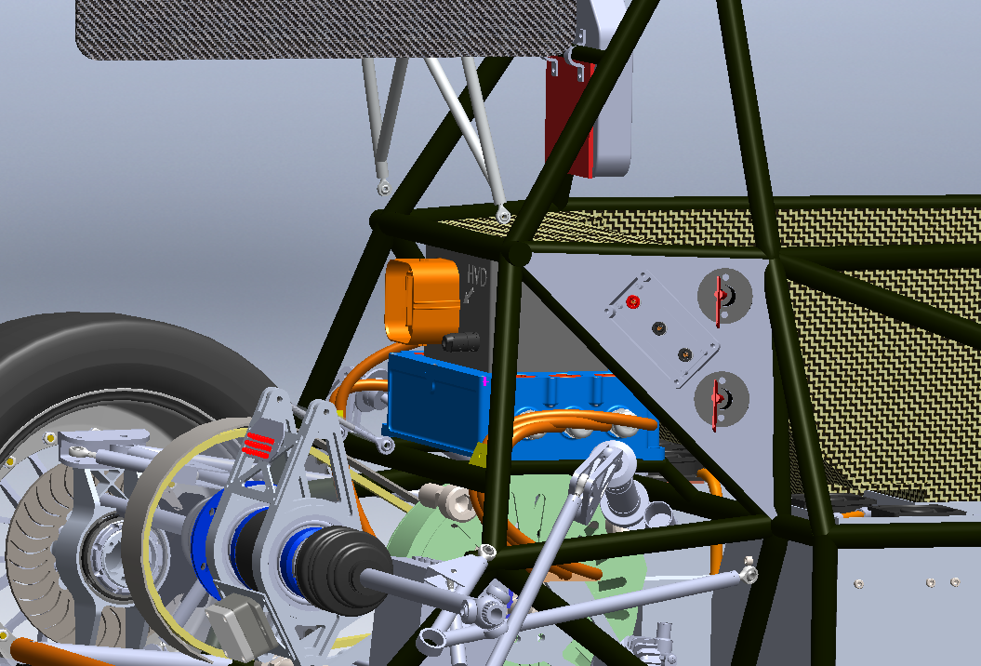

## Ready-To-Drive-Sound (RTDS)

### Description

Upon the Accumulator Isolation Relays closing, and the motor controllers turning on, a 24V car horn will turn on for more than one second and less than three to notify all that the vehicle is ready to drive. The horn (Piezzo) is driven by a mosfet driver. The signal that drives the buzzer is from the ECU with software. We are using a Mallory PT-4532PLQ. The horn is capable of generating 83bBA at 2 meters.

### Wiring, cables, current calculations, connectors

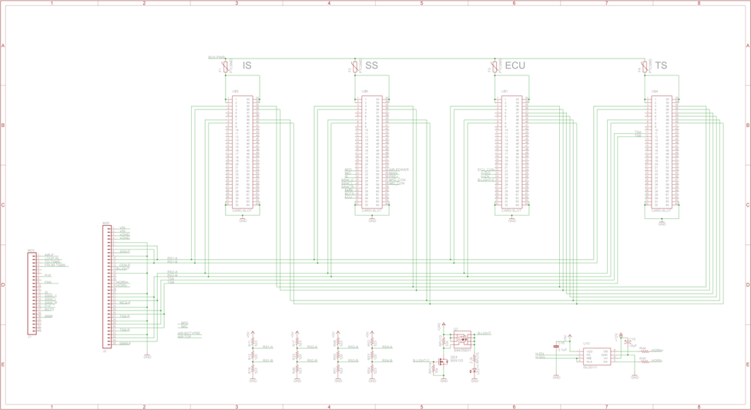

The Horn uses 24 Gauge PVC wire with a 300v and 105C rating. (10.16 Wire Datasheet) There are no connectors for the Horn. 10.16 datasheet

### Position in car

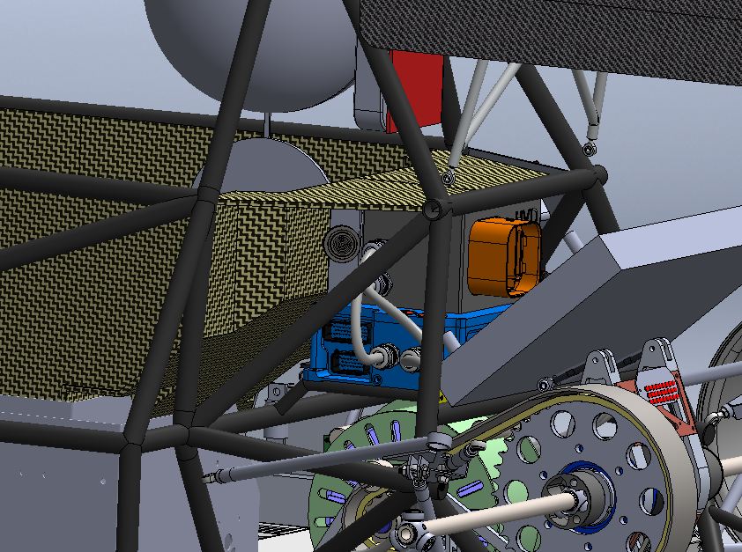

# Accumulator

## Accumulator pack 1

### Overview/description/parameters

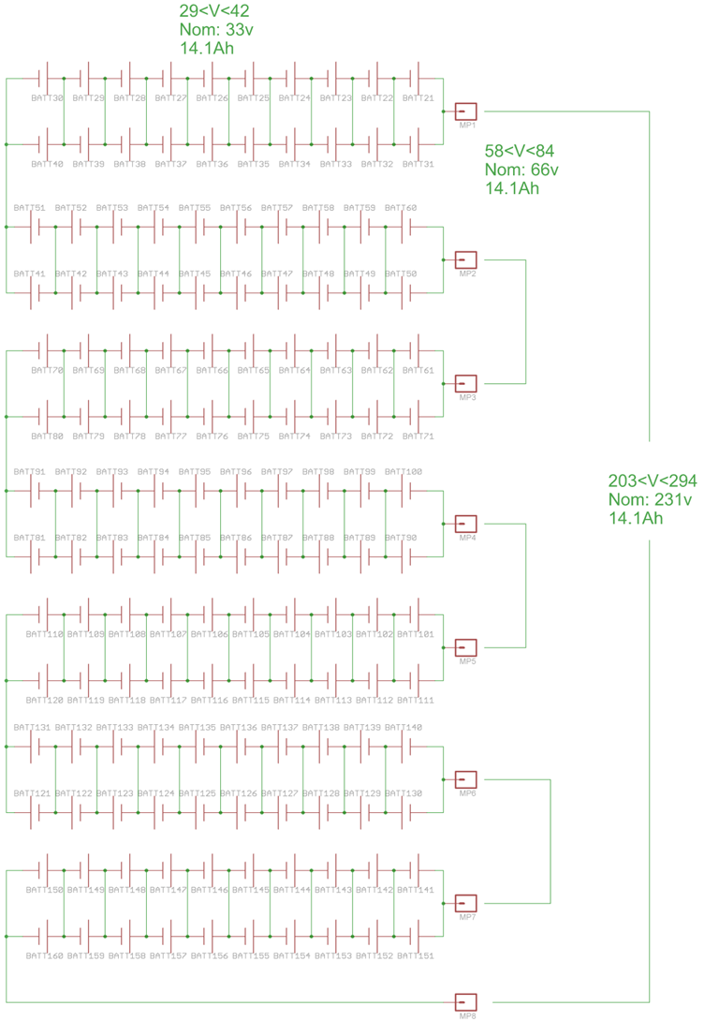

x2



Right (Box1-70s2p)

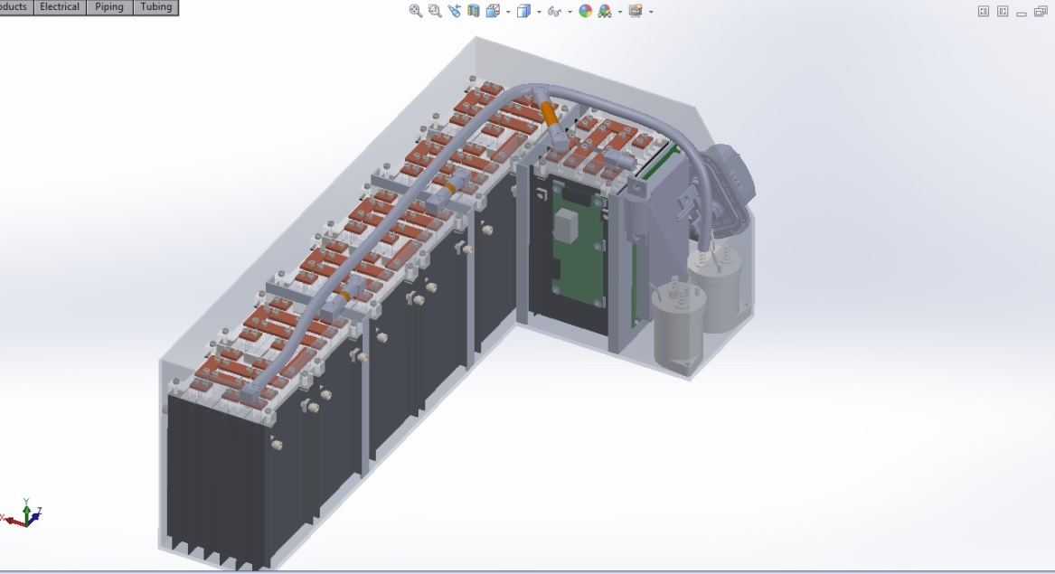

Left (Box2-70s2p)

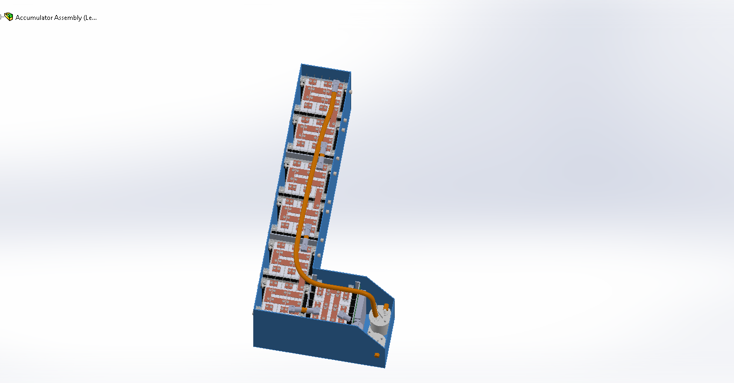

Modules (10s2p) x7 per container ~42v

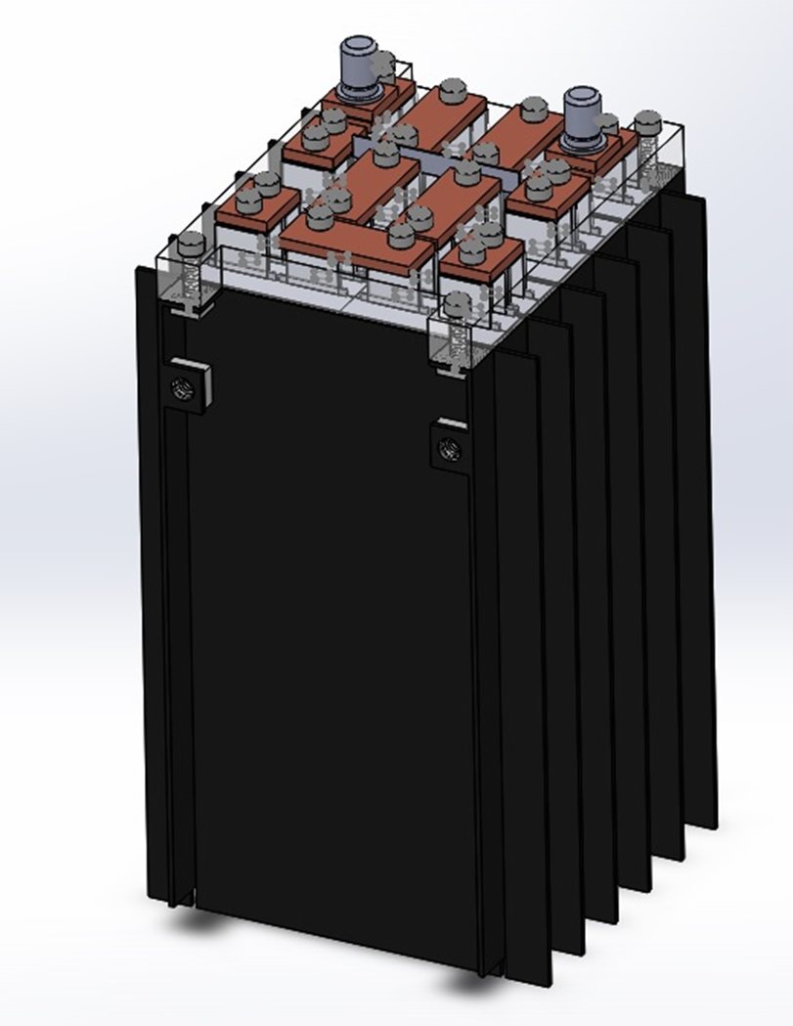

|  |  |
| --- | --- |
| Maximum Voltage: | 294VDC |
| Nominal Voltage: | 231VDC |
| Minimum Voltage: | 203VDC |
| Maximum output current: | 580A for 2s |
| Maximum nominal current: | 280A |
| Maximum charging current: | 28A |
| Total numbers of cells: | 280 |
| Cell configuration: | 70s4p |
| Total Capacity: | (7.05Ah)(3.3V)(3600j/Wh)(280cells)x10^-6=23.45MJ  (7.05Ah)(3.3V)(280cells)=6,514.2 Watt-hours |
| Number of cell stacks < 120VDC | 7 |

Table 3.1 Main accumulator parameters

### Cell description

|  |  |
| --- | --- |
| Cell Manufacturer and Type | Melasta SLPB9145180 |
| Cell nominal capacity: | 7.05 Ah |
| Maximum Voltage: | 4.2 V |
| Nominal Voltage: | 3.3V |
| Minimum Voltage: | 3.0V |
| Maximum output current: | 25C for 10s |
| Maximum nominal output current: | 20C |
| Maximum charging current: | 2C |
| Maximum Cell Temperature (discharging) | 60°C |
| Maximum Cell Temperature (charging) | 45°C |
| Cell chemistry: | LiPo |

Table 3.2 Main cell specification

HV Battery Cell Datasheet

### Cell configuration

Each accumulator contains 140 cells. The cells are separated in 7 segments containing 20 cells each. The segments are in a 10s2p arrangement. Each parallel cell in the segment is back to back. The cells are connected together by clamping custom copper bus bar on top of the tabs. This is shown in above figure.

### Cell temperature monitoring

Every cell will be monitored for temperature. We do this by putting an NTC resistor on the negative cell buss bar.

### Battery management system

280 cells will be monitored by the BMS that we made ourselves. 14 Slave devices with microcontrollers will communicate with one Master. This communication is done over RS485 and is isolated at each cell and master. The BMS is capable of opening a relay in the shutdown circuit to open the AIRs in the case of an error. At a minimum cell voltage of 3.8 and a maximum of 4.2, the BMS will take actions to bypass the affected cell(s). The BMS also reacts to problems as follows: Short cell (0v), blown fuse (2.5v biases present), and Over 60 degrees C. These all end in a safety shutdown by removing power to the AIRs. The BMS can also measures current with a high side current shunt with orange wire. The BMS shuts down the tractive system via a relay that is tied into the safety loop. That would trip the safety system and the car would shut down. These boards are linked with locking Molex connectors. This allows for hot swapping boards. The slave boards are mounted to the sides of the modules. There is wire going between the BMS PCB and the Battery pack. We have PCB inline fuses to protect the brown BMS sense wires. (Datasheet BMS sense fuse) Isolation is on two items the BMS and the Iso board. The devices on these parts keep isolation up to 2.5 kV. (Device marked with red indicators on the schematics)



BMS board:

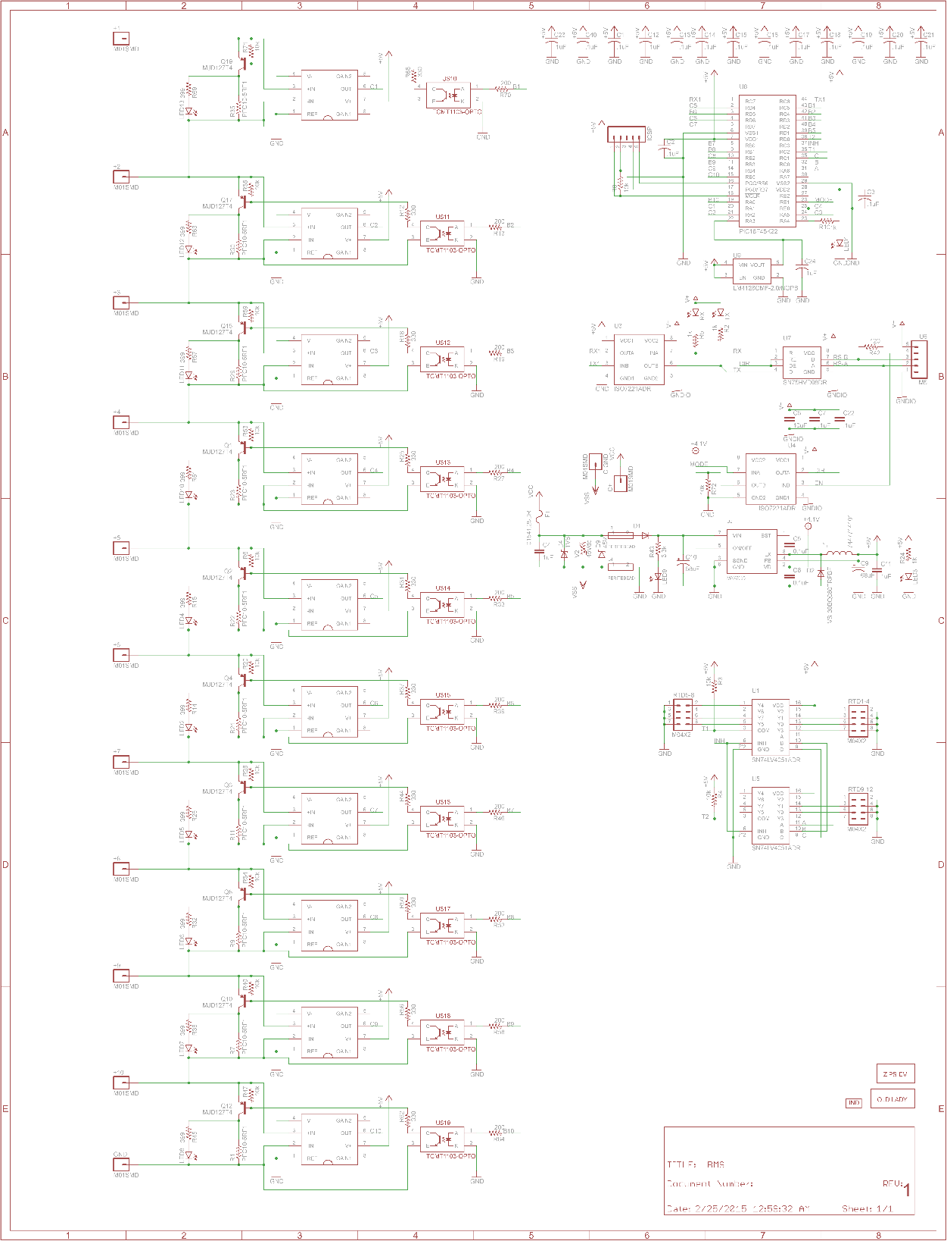

BMM Board:

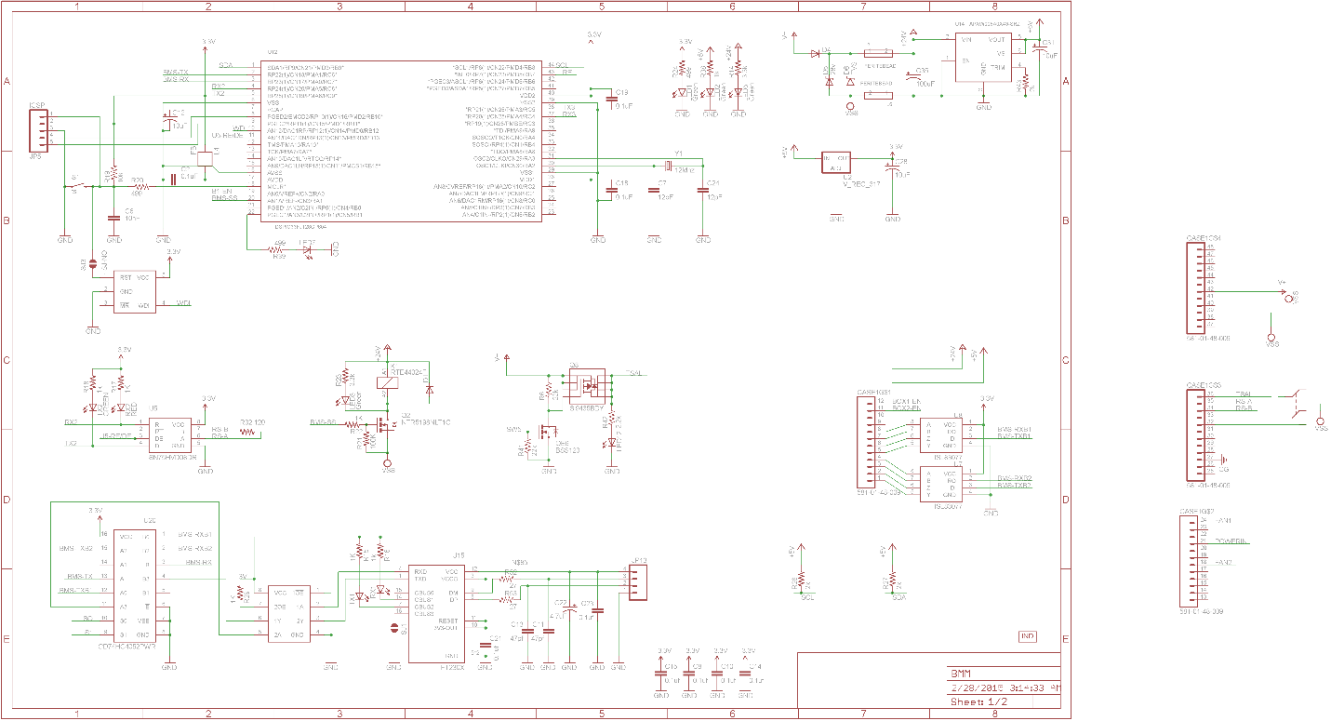

Iso Board:

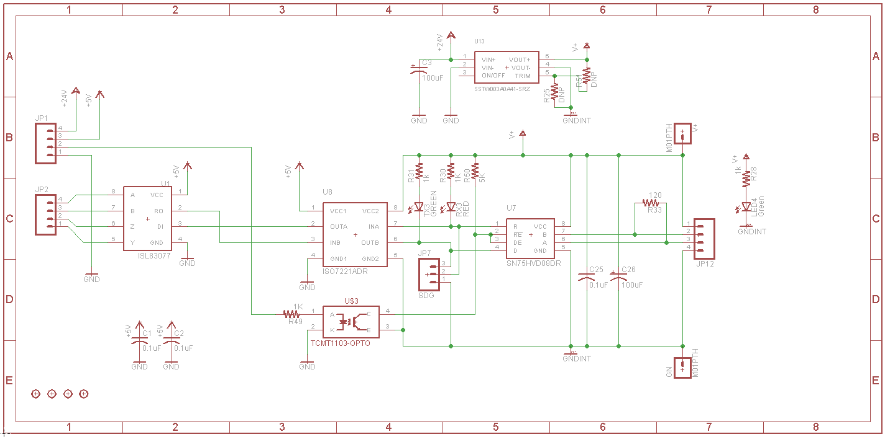

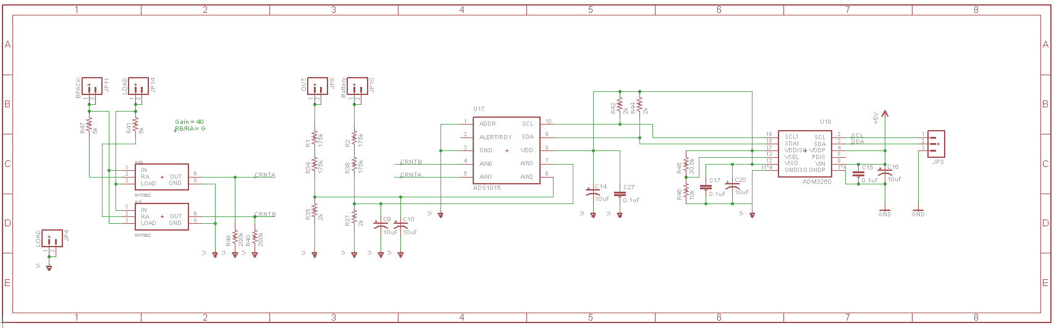

### Accumulator indicator

The accumulator indicator is an LED that will be attached to the battery enclosure to indicate that the pack is active. This indicator will be wired across the first and last AIR’s, so that it is powered when there is voltage on the vehicle side of the accumulator container. It therefore the circuit below is only powered from tractive system voltage. It does not run off of the GLVS and therefore work outside of the car. The wire used for this AWG 22. The circuit bellow illuminates the LED and TSAL at 60V.



### Wiring, cables, current calculations, connectors

|  |  |
| --- | --- |
| Wire type | Alpha Wire 1855 (data sheet Hookup wire) |
| Continuous current rating: | 7A |
| Cross-sectional area | 0.030 in |
| Maximum operating voltage: | 300V |
| Temperature rating: | 105 °C |
| Wire connects the following components: | Cell and BMS |

Table 3.3

GLV wire enters the black connector in photo. The wire then is bundled with high temp, high voltage rated heat shrink into a bundle going to the iso board.



### Accumulator insulation relays

|  |  |
| --- | --- |
| Relay Type: | EV200AAANA |
| Contact arragment: | SPST |
| Continous DC current rating: | 500A |
| Overload DC current rating: | N/A |
| Maximum operation voltage: | 900VDC |
| Nominal coil voltage: | 24VDC |
| Normal Load switching: | Make and break up to 500A |
| Maximum Load switching | 10 times at 1500A |

Table 3.4 Basic AIR data

AIR Data sheet

### Fusing

We use two main fuses in the car. One in each bank that fuses the outputs of each individual box. The fuse holders we are using are the LSCR001 from little fuse. They are 600v, 400A rated fuse holder.

|  |  |
| --- | --- |
| Fuse manufacturer and type: | Littelfuse, Class T |
| Continous current rating: | 150A |
| Maximum operating voltage | 300VDC |
| Type of fuse: | High speed |
| I2t rating: | 1500A2s at 450VDC |
| Interrupt Current (maximum current at which the fuse can interrupt the current) | 20000A |

Table 3.5 Basic fuse data

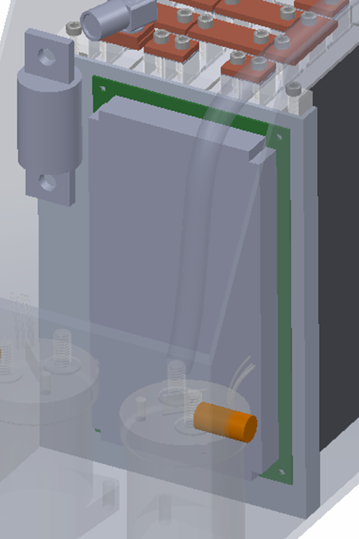

|  |  |  |  |  |
| --- | --- | --- | --- | --- |
| Location | Wire Size | Wire Ampacity | Fuse type | Fuse rating |
| Cells to AIRs | 2 AWG | 255 | 2x MNO Fuse | 145 |
| AIR to Motor controller | 2 AWG | 255 | N/A | N/A |
| AIR to TSAL | 24 AWG | 3.5 | EFG Fuse | XXX |
| Accumulator output connector | 2 AWG | 300 |  |  |
| Cells to BMS | 22 | 7 |  |  |

Table 3.6 Fuse Protection Table

### Charging

The battery charging will use the battery management system to control the charger. The BMS-master by default is not able to talk to the charger directly and control the AIR's.. We designed a charging control adapter board that hosts the interfaces and isolation necessary to follow the rules of the competition. This board also hosts the safety system for the IMD, control relays, lights and LCD display.

|  |  |
| --- | --- |
| Charger Type: | SmartCharge-12000 |
| Maximum charging power: | 12kW |
| Maximum charging voltage: | 350V |
| Maximum charging current: | 70A |
| Interface with accumulator | serial communication |
| Input voltage: | 120-230 VAC |
| Input current: | Up to 50A |

Table 3.7 General charger data

### Mechanical Configuration/materials

The accumulator design features two separate contains each housing 140 cells along with accompanying components and PCBs. These containers are designed to be easily removable for charging and servicing. The HV warning sticker for these accumulators will be positioned on the exterior walls near the HV connector. The connectors being used in the design incorporate an interlock, however additionally these connectors will be zip tied to ensure full connection with the port. The housing of the container is made up of 5 components; 3 side panels, 1 floor plate, and 1 lid. To minimize the number of fasteners used in the overall assembly, bending of the side walls was utilized. Where the 3 side walls mate are 3 bolted joints where 3 ¼” bolts are used to secure them. Flanges were also designed to mate with the floor plate and the corresponding jointed connection rules were followed. The lid of the housing is secured via 6 bolts to ensure the lid is secure to the rest of the housing. The accumulator will also have holes/ports for cooling aspects. Holes are included in both the lid and the bottom plate, these holes enable for an even flow of air through the cell segment walls. The holes on the lid mate with 24 volt PC fans that use filters and tubing to the front intake to ensure water is not leaked into the container. The holes on the bottom exit to an area that does not experience water and therefore not necessary to seal.

The design of the battery segments incorporates an array of aluminum partitions. These partitions interlock with each other and are fastened into the accumulator via bolts to the sidewalls. The partitions are designed and assembled in such a way so that cells are compressed to an allowable pressure and thus ensuring that they are securely in place inside the segment wall assembly. The electrical tabs of the cells are connected using a series of copper busbars. The busbar width (0.600”) and thicknesses (0.0625” and 0.125”) were determined using formulas from the current that will be witnessed in through the cells. The busbars themselves are secured via a bolted method that incorporates a steel mounting plate with a threaded hole to accept the bolt that runs through the busbar and the cell tabs. The bolts are locked to the busbar with a Belleville Washer to increase the distribution of pressure to the busbar and to ensure loosening doesn’t occur over time. The busbars are oriented to the cell segments via an acrylic pattern that is mechanically attached to the top of the segment wall assembly. These acrylic patterns create electrical separation/insulation between the busbars and thus prevents arching. Terminal rings will be used to route the current sense from the cells to the BMS and these will be secured underneath the bolt used to secure the busbar. The BMS boards for each electrical segment are located along the vertical sides of the segment wall assembly. To connect the electrical segments together in accordance to the rules quick disconnects were designed in. This quick disconnects satisfy the need for maintenance plugs because the electrical segments are under the 6MJ and 120V limit. We are using the 6648223-1 from TE with a boot to cover up the connector. Maintenance Plugs

The accumulator features a separate compartment for components of the accumulator that need to be electrically isolated. Each compartment inside the accumulator is electrically isolated by aluminum dividers wrapped in Kapton tape. Inside this component compartment AIRs, fuses, connectors, relays, current sense, resistors among other are located. These components are arranged in a way to prevent low voltage wiring from violating the 1.2” electrical insulation requirement. Also included in this compartment is the Indicator Light, which is positioned directly above connector. This indicator light is of the panel mounted variation, therefore it can simply secure against the side of the accumulator wall.

### Position in car

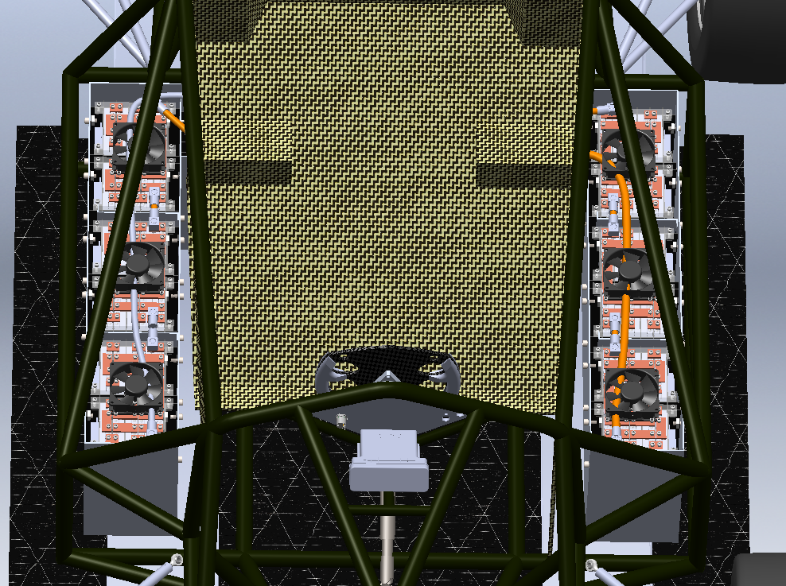

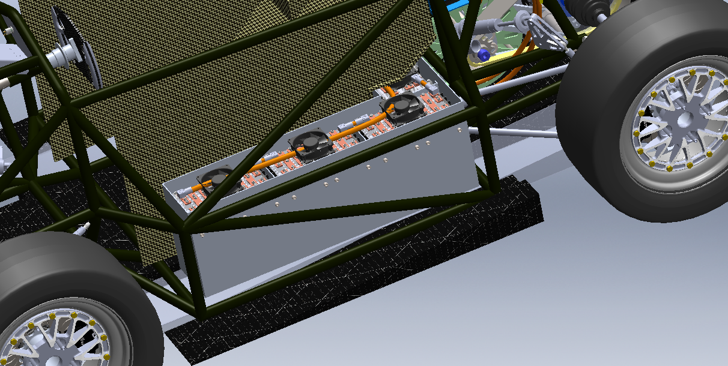

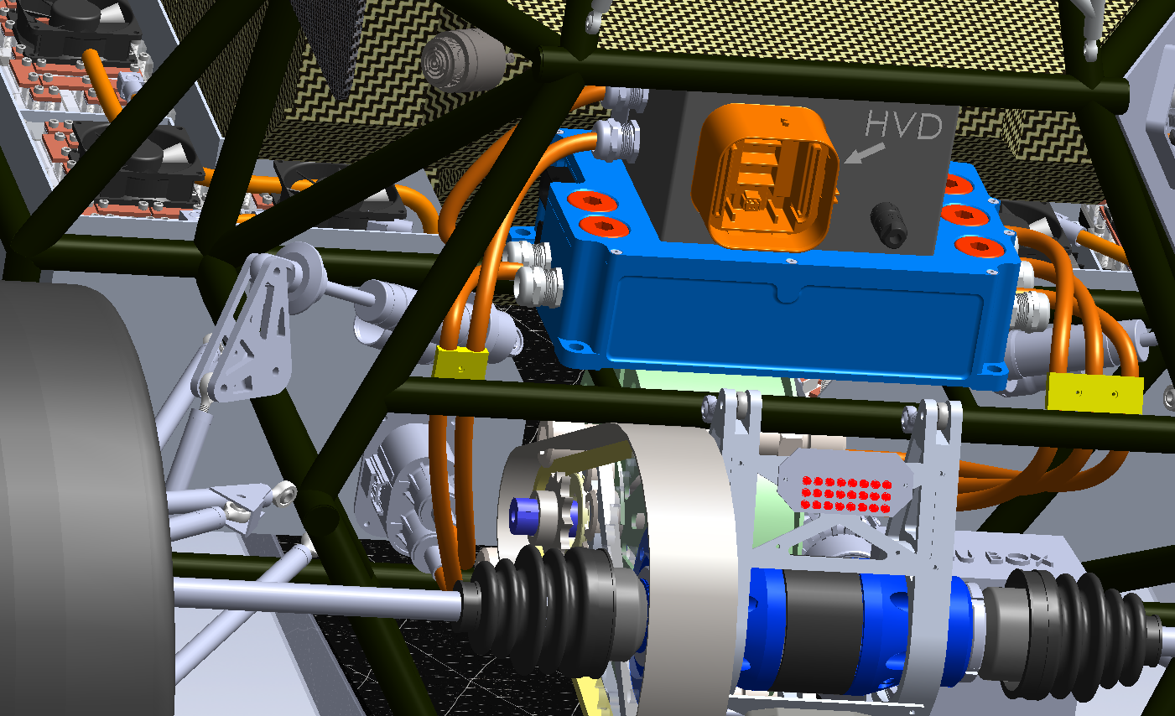

## Accumulator pack 2

# The second accumulator pack is exactly like the first.Energy meter mounting

## Description

Energy Meter will be connected between the ground of the accumulator and motor controller. It will measure the total energy used and calculate the efficiency.

## Wiring, cables, current calculations, connectors

All connections to the accumulator, the motors, and the energy meter are all Exrad XLE 2 cable. We have a 1A fuse between the TS+ and the HV sense input on the box.



## Position in car

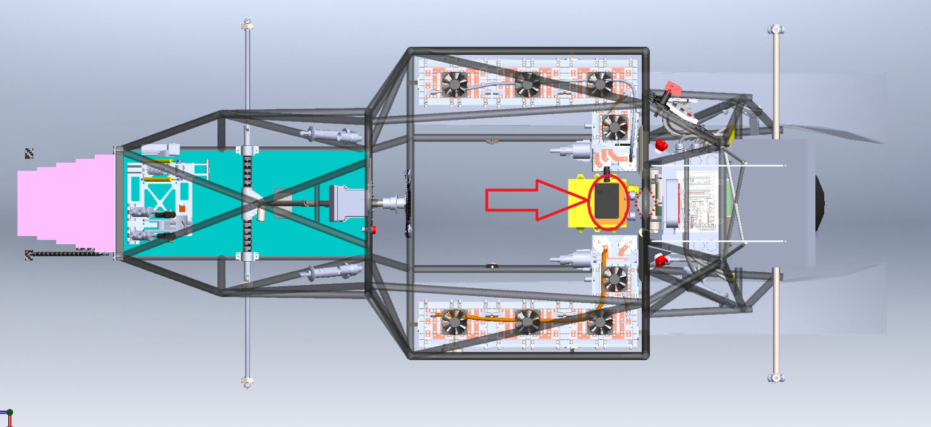

# Motor controller

## Motor controller 1

### Description, type, operation parameters

The PM100DX from Rinehart Motion Systems we are using are permanent magnet brushless AC motor controllers. They are capable of 0-360V and 300Arms. The motor controllers are commanded via analog signals sent by our self-designed motor controller PCB (MCS). It communicates over a RS485 communication bus from the ECU. The motor controllers also control the regenerative braking of the car. This is set from hardware controlled by our software. The controllers are isolated. Because of that, nothing connecting to them needs isolated from chassis ground.

|  |  |
| --- | --- |
| Motor controller type: | RMS PM100DX brushless AC |
| Maximum continous power: | 108kW |
| Maximum peak power: | 126kW for 30s |
| Maximum Input voltage: | 360VDC |
| Output voltage: | 250VAC |
| Maximum continuous output current: | 300Arms |
| Maximum peak current: | 350Arms for 30s |
| Control method: | analog signal |
| Cooling method: | water |
| Auxiliary supply voltage: | 12VDC |

Table 4.1 General motor controller data

### Wiring, cables, current calculations, connectors

All connections to the accumulator, the motors, and the energy meter are all Exrad XLE 2 cable. The motor controller will do all of our shield grounding for us on the High power cable. They go through grounding cable glands. This makes a sealed connection. The conductor is clampe in a bus bar in the motor controller.

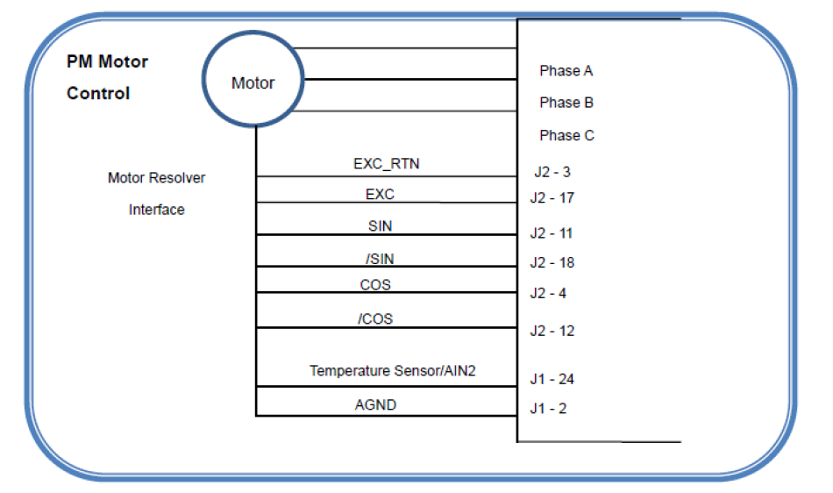

|  |  |
| --- | --- |
| Wire type: | Champlain Exrad xlx2x |
| Current rating: | 255A |
| Maximum operating voltage: | 1000V |
| Temperature rating: | 240 °C |

Table 4.2 Wire data of company A, 0.205 mm²

### Position in car



## Motor controller 2

There is only one motor controller.

.

# Motors

## Motor 1

### Description, type, operating parameters

|  |  |
| --- | --- |
| Motor Manufacturer and Type: | Enstroj EMRAX228 HV |
| Motor principle | Brushless Synchronus Three Phase AC |
| Maximum continuous power: | 45kW |
| Peak power: | 100kW for 3s |
| Input voltage: | 50-600Vdc |
| Nominal current: | 115A |
| Peak current: | 240A |
| Maximum torque: | 240Nm |
| Nominal torque: | 125Nm |
| Cooling method: | Water |

Table 5.1 General motor data

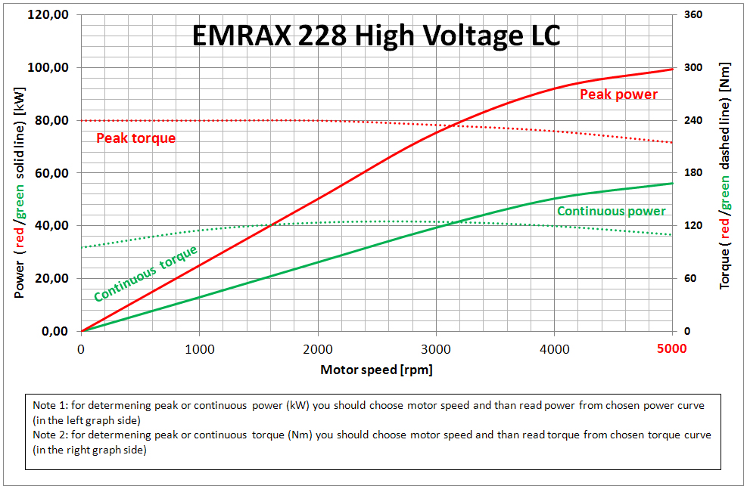

### Wiring, cables, current calculations, connectors

The three shielded wires coming to the motor have 90 degree crimp terminals and then bolted on to the connections to the motor. We are adding locking nuts to prevent looseness of the connection. We are 3D printing a cover that goes over these terminals to provide isolation spacing and protect people.

### Position in car

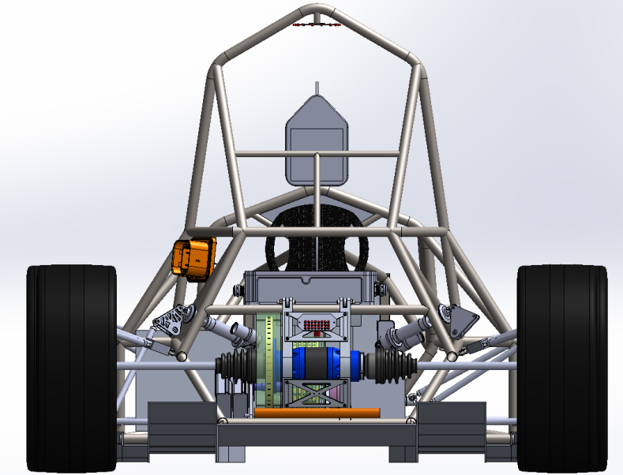

## Motor 2

We only have one motor in the car.

# Torque encoder

## Description/additional circuitry

The two CLS1322-075 sensors are linear displacement sensor. They will be connected to the throttle pedals of the vehicle. As the pedal moves the sensor will slide with the pedal and provide an analog output to the system. That output will be sent as an input to a conditioning circuit. Once conditioned, the signal will be sent to the main controller.

|  |  |
| --- | --- |
| Torque encoder manufacturer and type: | CLS1322-075 |
| Torque encoder principle: | potentiometer |
| Supply voltage: | 3.3V |
| Maximum supply current: | 20mA |
| Operating temperature: | -20..180 °C |
| Used output: | 150mV-3.2V |

Table 6.1 Torque encoder data

## Torque Encoder Plausibility Check

If an error occurs in the measuring requested torque from the throttle pedal the main controller will shut the vehicle down. A number of errors could occur. If the communication is lost between the SAS (Where the analog signal is measured) and ECU the car will be shutdown (AIR’s opened). If at any time the conditioning circuit is shorted or becomes open the controller will see the loss of signal (30ms) and will shut the car down. If the outputs of the two potentiometers differ by more than 10% the vehicle will be shut down as stated in the rules.

We check for above failures by first, monitoring data integrity by using CRC check sums in serial data and in code. We monitor position sensors integrity by using the sensors as rheostats and adding a 5 ohm resistor in series with the sensor. We added a 100 ohm pull up on the ADC pin. With the sensor connected to the ADC pin to ground we can measure all fault modes.

The analog output to the motor controller is made created by an I2C DAC. It is buffered by an op-amp. That signal goes to a SPDT relay. The output to the motor controller is on the common pin. The DAC is connected to the NO pin. The NC pin is pulled to ground. The uC reads the DAC to verify output matched set point. If they match, the relay opens and stays open as long as the car is on and output matches set point.

## Wiring

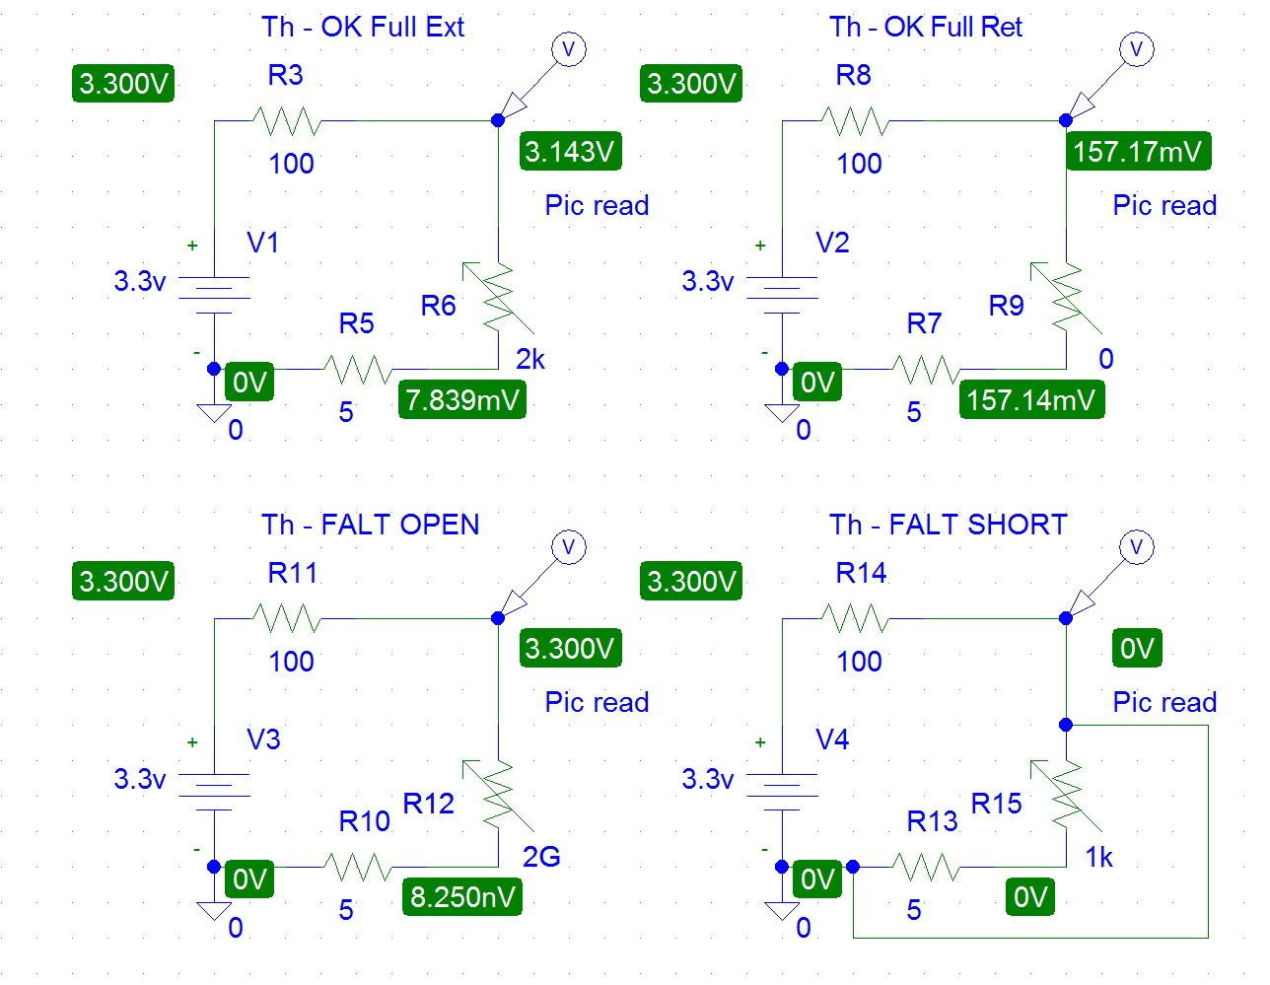

## Position in car/mechanical fastening/mechanical connection

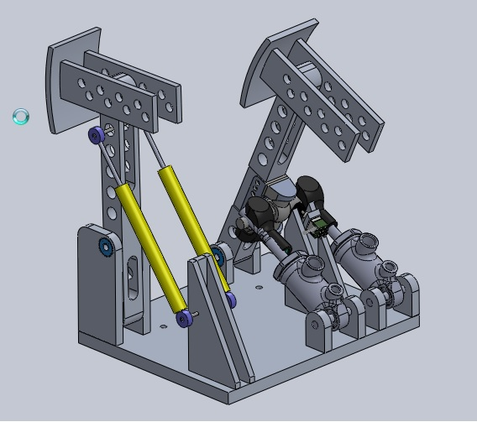

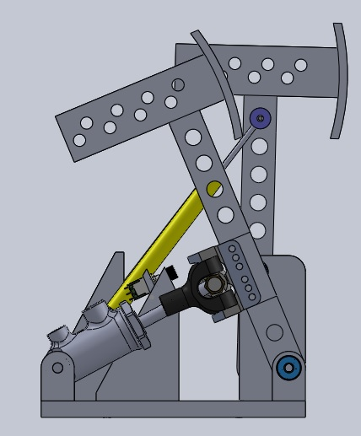

# Additional LV-parts (Custom BMS for GLVS)

## LV part 1 – GLVS

Our GLVS is powered by a custom battery pack. This pack is protected by a student designed battery management system that is from a reference design from Design Flux Technologies.

### Description

7cells will be monitored by the BMS that we made ourselves. The BMS is capable of opening a relay to disconnect the pack. This removes all GLV power to the car, shutting the car down. The BMS will monitor cells for minimum voltage of 2.75v and a maximum of 4.2. Our BMS will take actions to bypass the affected cell(s) of higher voltage and shutdown the GLVS system if necessary. The BMS also reacts to temperature problems at 60°C. The BMS can also measure current and trigger the safety system. There is a wire going between the BMS PCB and the Battery pack.

### Wiring, cables,

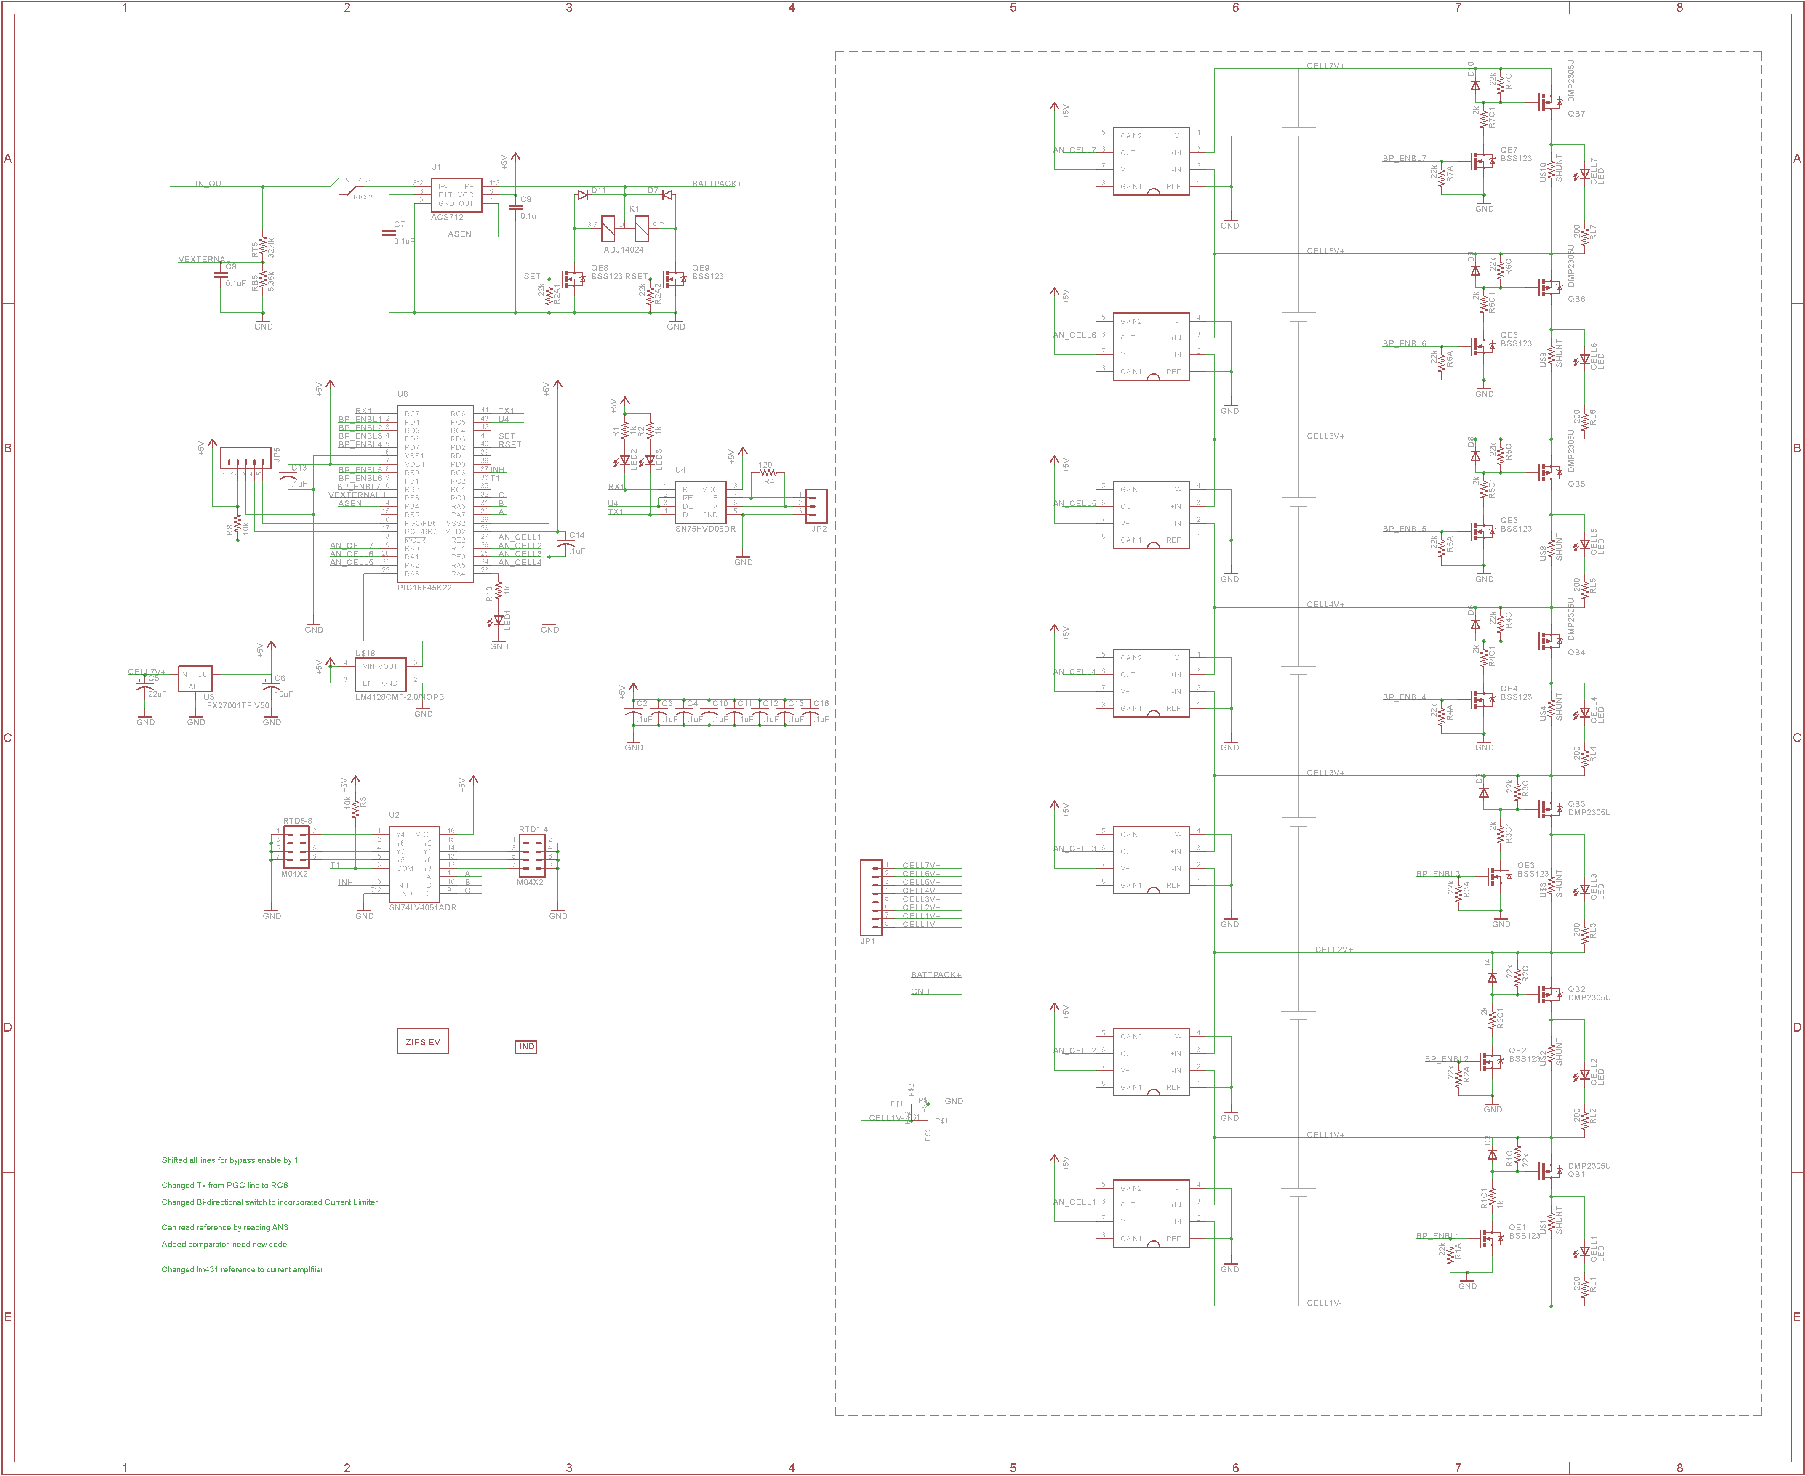

### Position in car

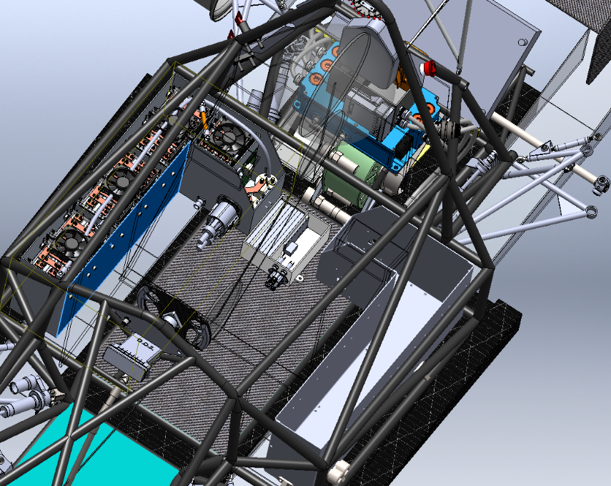

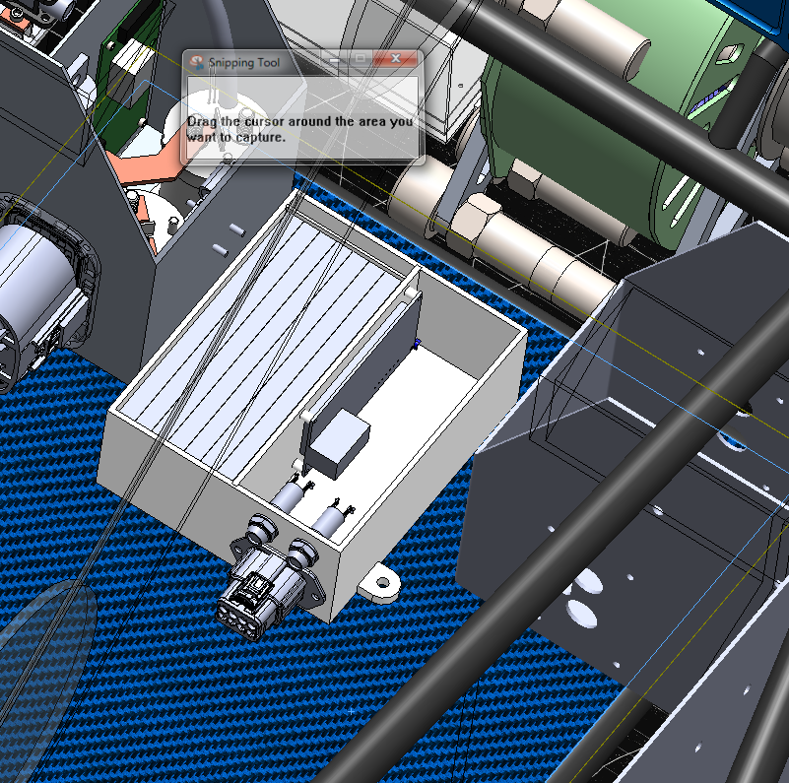

## LV part 2

N/A

# Overall Grounding Concept

## Description of the Grounding Concept

The chassis is made from conductive chrome-moly and will provide low resistance paths through the frame. The steering wheel will have a ground wire thru the disconnect to insure low resistance. Firewalls will be mounted to the car with tabs welded to the frame. The tabs will have paint removed to make a solid electrical connection to the firewall

## Grounding Measurements

GLVMP location. GLV battery lead comes out and lands on a frame bolt.

# Firewall(s)

## Firewall 1

### Description/materials

The Tractive System Firewall serves purpose of not only protecting the driver from potential hazard, but also supporting the driver in the car. Because the seat is molded foam and not rigidly mounted to the chassis, the firewall must be capable of supporting the driver's torso and seat throughout the dynamic events. The proposed firewall is a composite structure consisting of fire retardant materials. This allows us to make a stiff panel that is also fire resistant. The concept, attached below, consists of an aluminum skin (0.5 mm thick) facing the HV components (per the required firewall rules) and fire resistant core materials, followed by a Kevlar skin. A thick kevlar skin will be sufficient in preventing piercing of the firewall, and the honeycomb structure will give the panel enough stiffness to support the loads required. The firewall is grounded to the chassis via the mounting system used to secure it to the chassis. This consists of Socket head cap screws through the firewall and tabs welded directly to the chassis. In the event that this grounding method is not sufficient, a properly sized grounding strap will be added to the aluminum skin to which travels to the chassis.

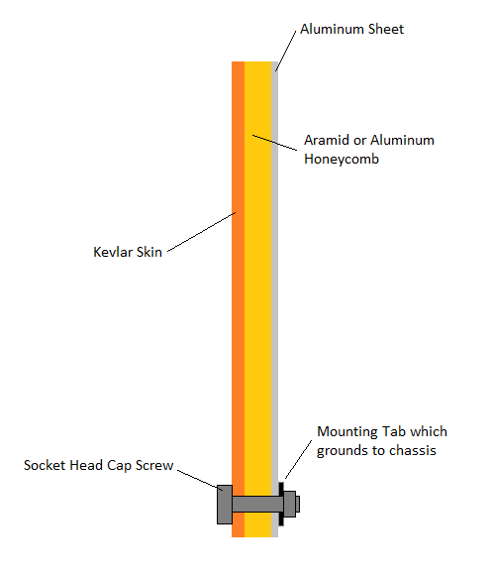

### Position in car

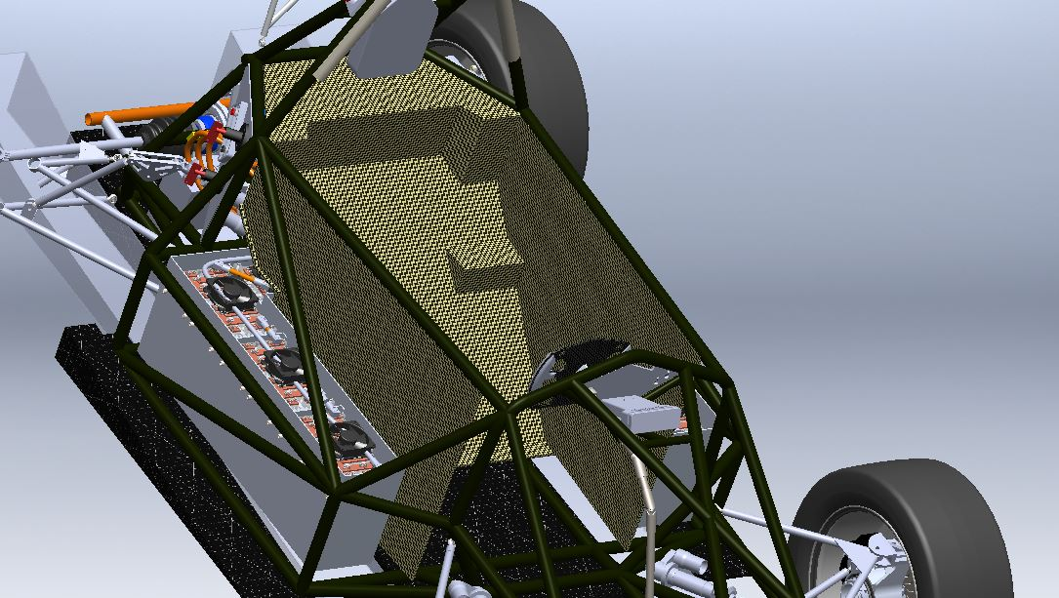

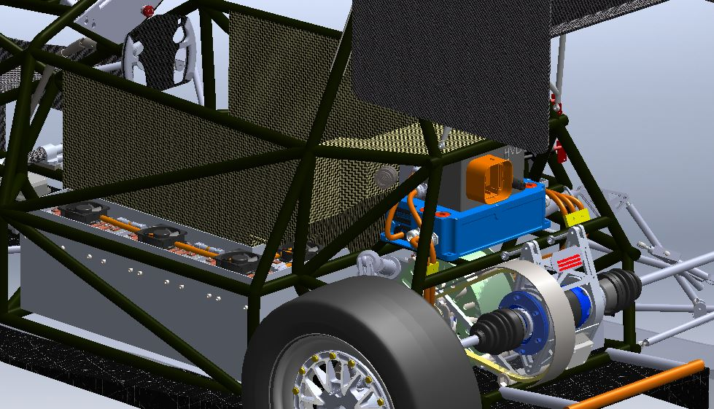

## Firewall 2

We only have one firewall in the car.

# Appendix

## HV Battery Cell Datasheet

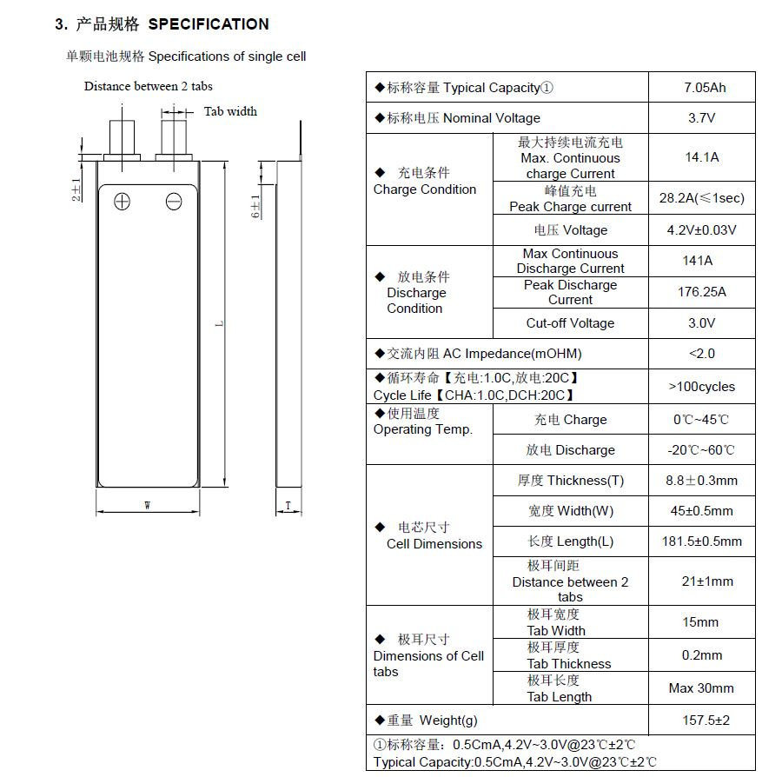

<http://www.melasta.com/product.asp?lie=Lithium%20polymer%20battery>

## AIR

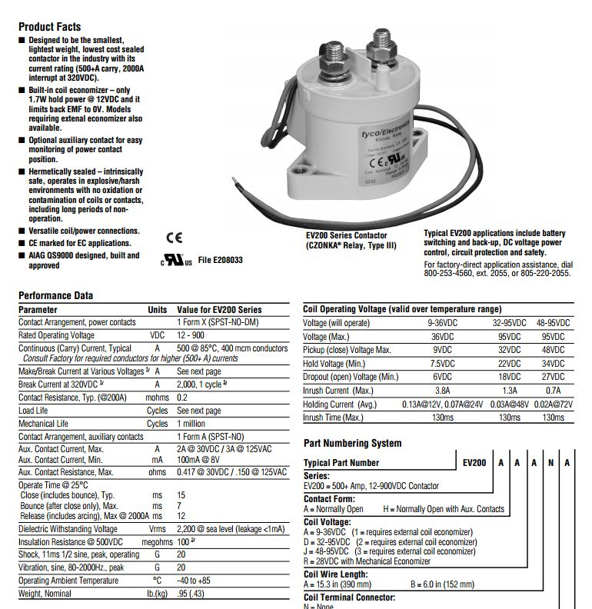

<http://www.te.com/catalog/pn/en/1618002-7>

## Maintenance Plugs

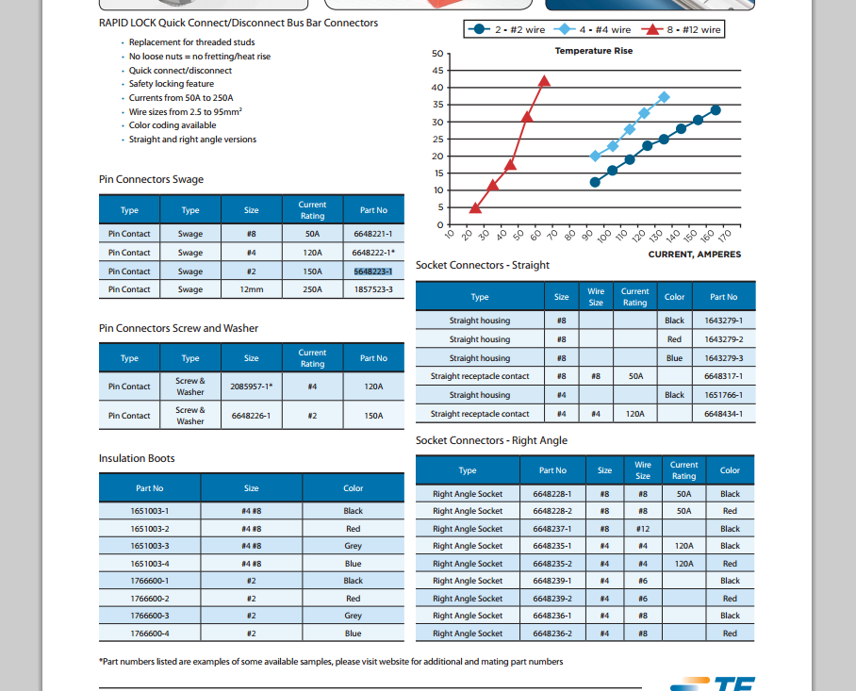

More info at :

<http://www.te.com/usa-en/product-6648223-1.html#pdp-docs-features>

## HV cable

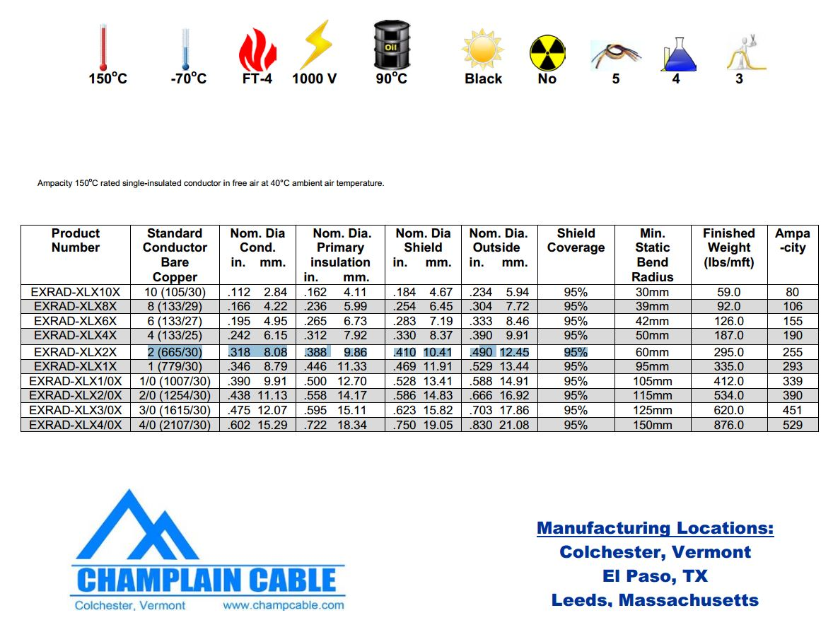

More information at <http://www.champcable.com/product_pdfs/14_SAE_XLE_Shielded_High_Voltage.pdf>

## Crash Sensor

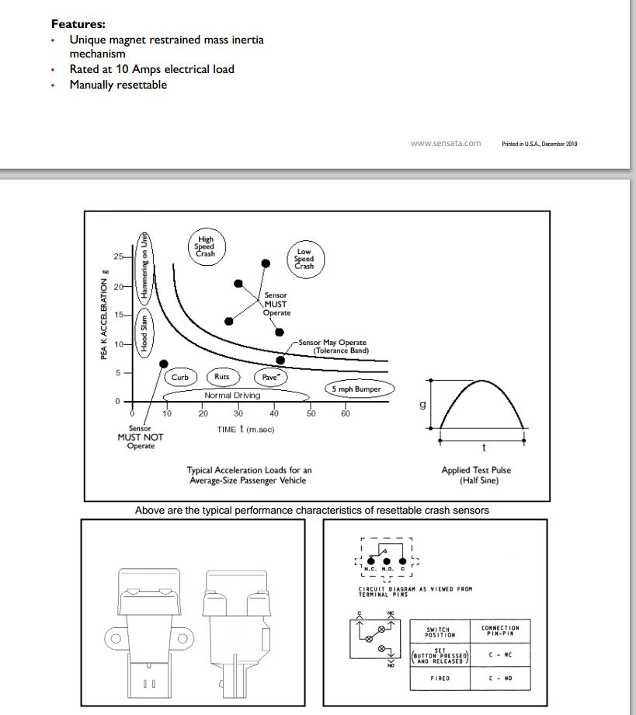

<http://www.sensata.com/download/resettable-crash.pdf>

## IMD

Referred from 2.1.1.

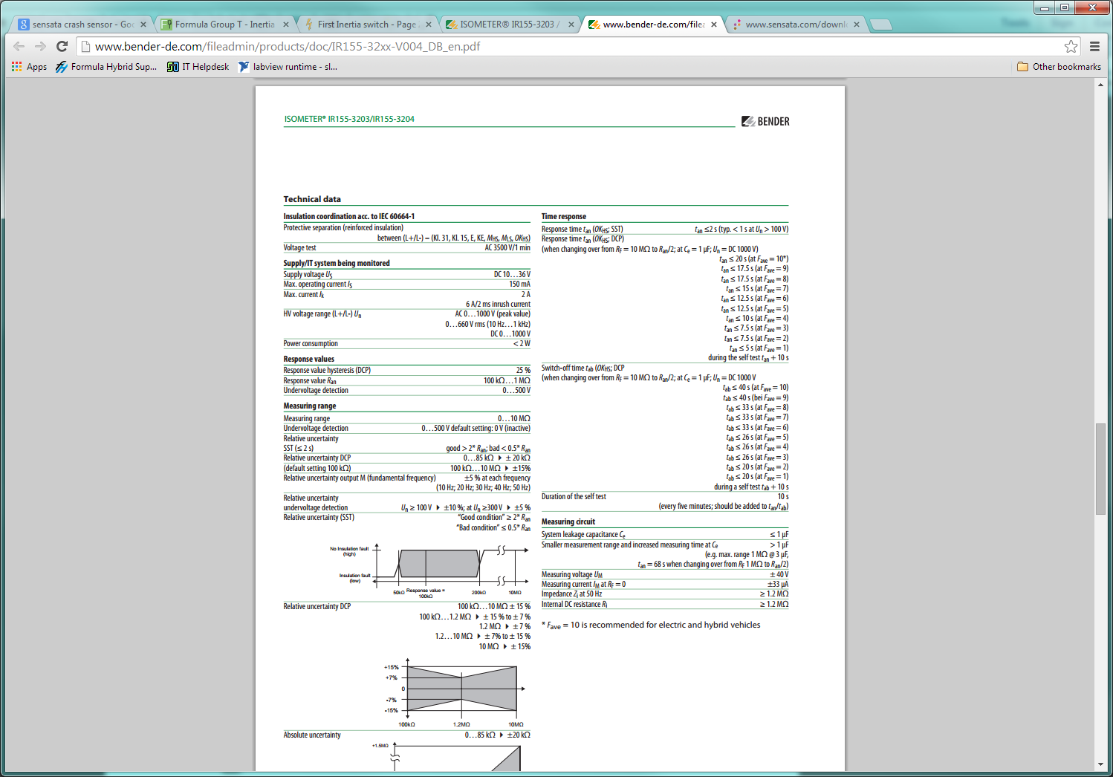

Complete data sheet located at: <http://www.bender-de.com/fileadmin/products/doc/IR155-32xx-V004_DB_en.pdf>

## HV Fuse

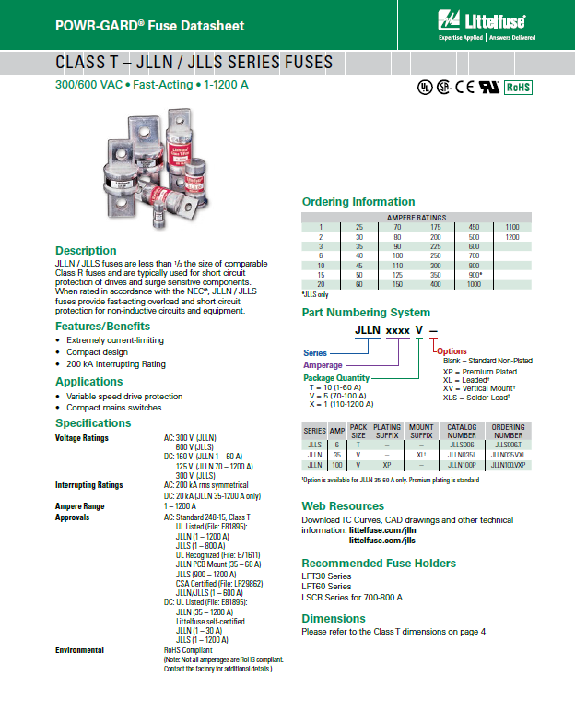

## Motor Controller



<http://www.rinehartmotion.com/files/Download/PM_Datasheet_01052012.pdf>

## Motor

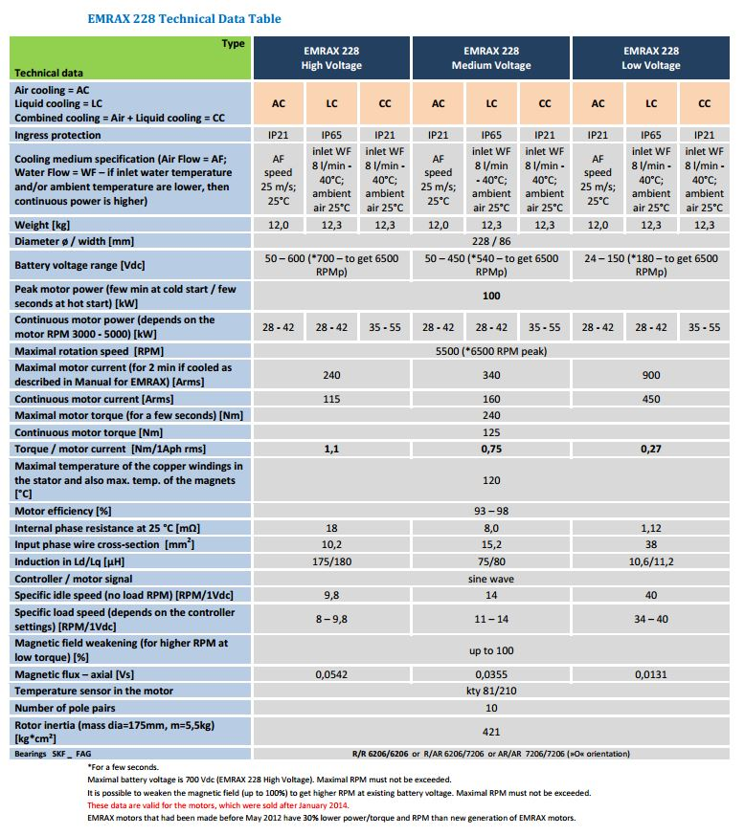

<http://www.enstroj.si/Electric-products/emrax-228-motorsgen.html>

## Lov Voltage Battery

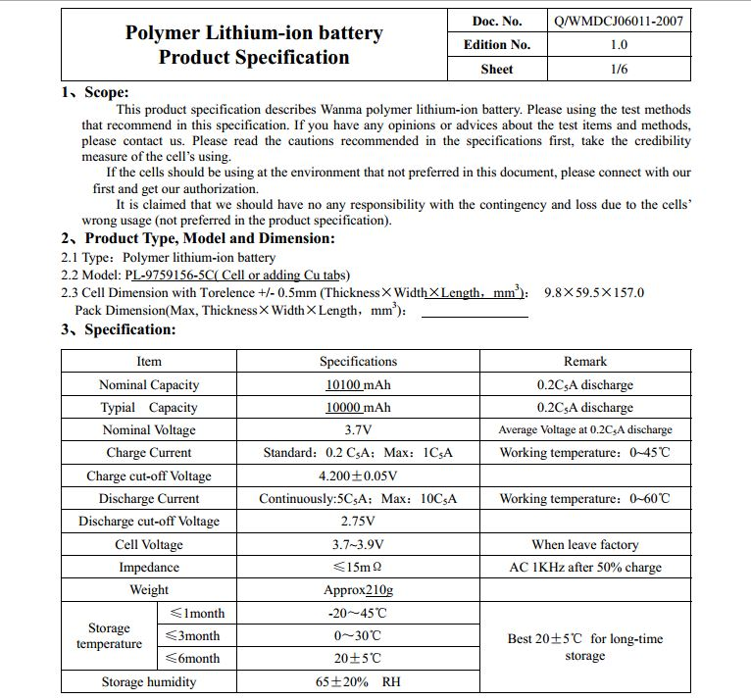

<http://www.batteryspace.com/prod-specs/3.7V10Ah.pdf>

## TSMP

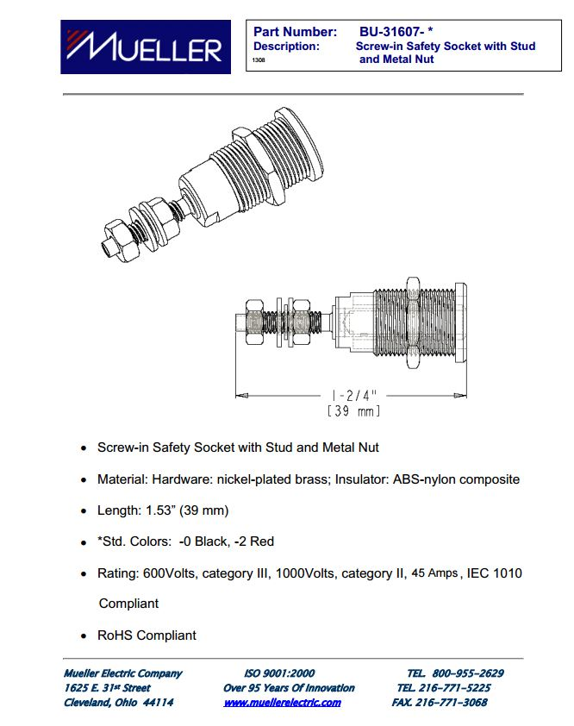

Full datasheet: <http://muellerelectric.com/wp-content/uploads/DS-BU-31607-0.pdf>

## TSMP-Resistors



Full datasheet: <http://www.te.com/commerce/DocumentDelivery/DDEController?Action=srchrtrv&DocNm=1773278&DocType=DS&DocLang=English>

## HVD

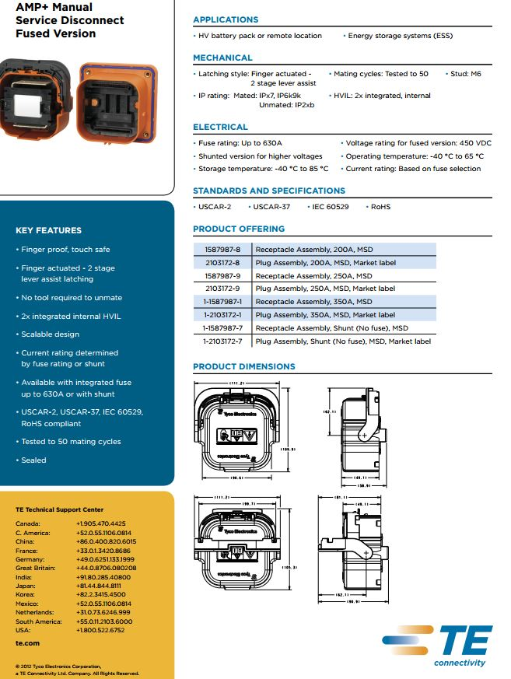

Full Datasheet: <http://www.te.com/content/dam/te/global/english/industries/hybrid-electric-mobility-solutions/amp-msd-tech-sheet.pdf>

## E-Stop

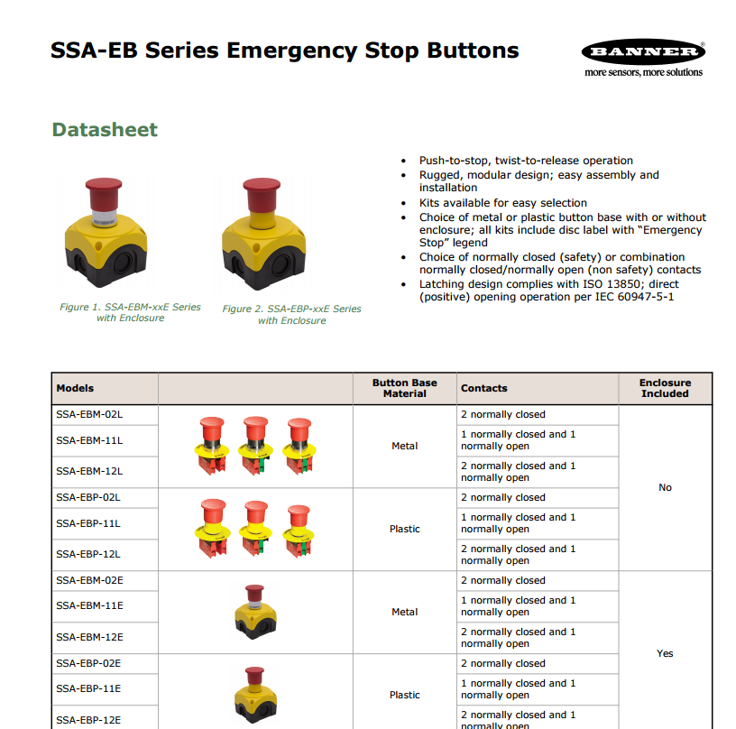

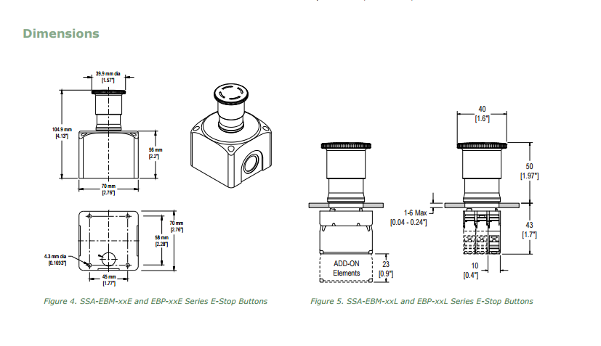

Full Datasheet: <http://info.bannersalesforce.com/cs/groups/public/documents/literature/111880.pdf>

## TSMS / HV sense wire

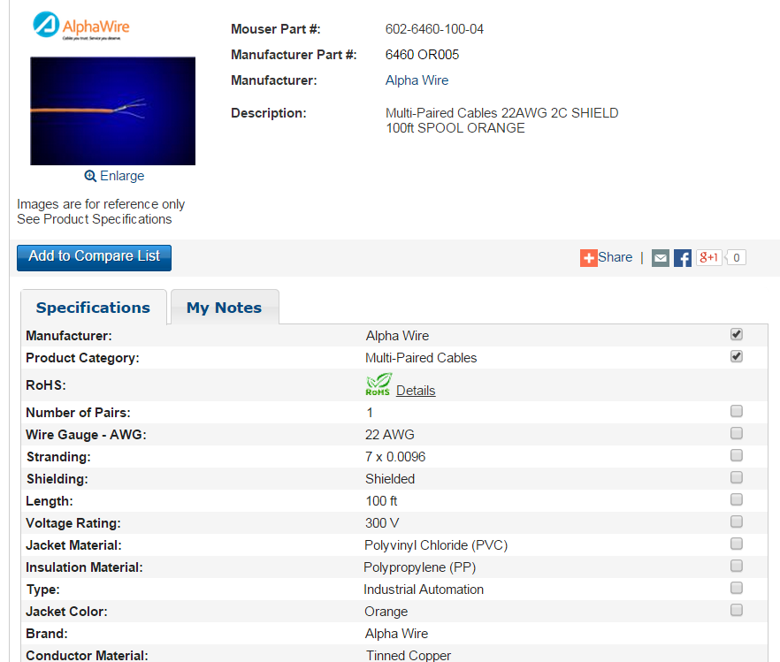

Full datasheet: <http://www.mouser.com/ProductDetail/Alpha-Wire/6460-OR005/?qs=sGAEpiMZZMv1%2f%252b2kKkGMBdDOvp5WNg%252bt9emRXpKWYqs%3d>

## Hookup wire

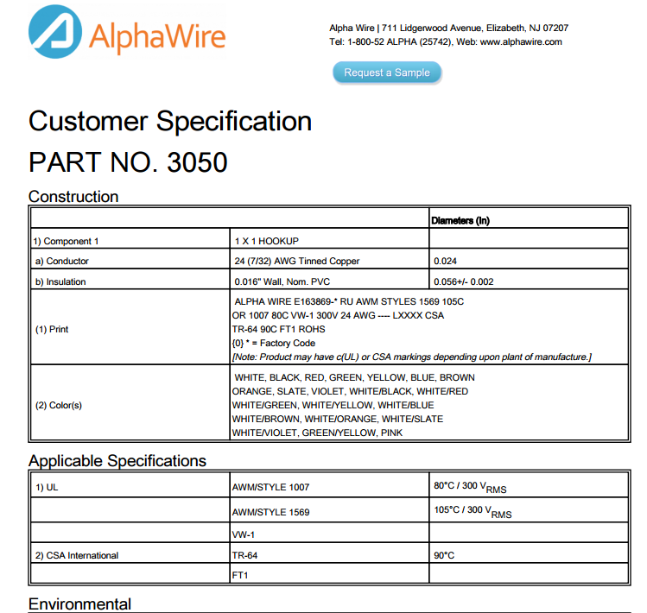

Full Datasheet: <http://www.alphawire.com/Home/Products/Wire/Hook-Up-Wire/Premium/3050?device=pdf>

## Brake Pressure sensor

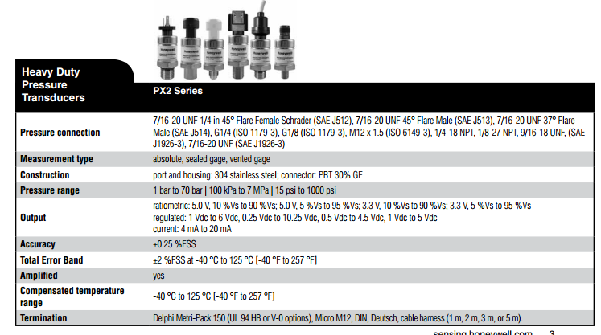

Full datasheet: <http://sensing.honeywell.com/index.php?ci_id=54928>

## BMS sense fuse



Full datasheet: <http://belfuse.com/pdfs/C1F.pdf>